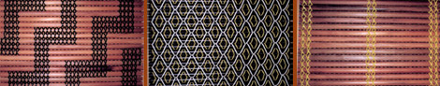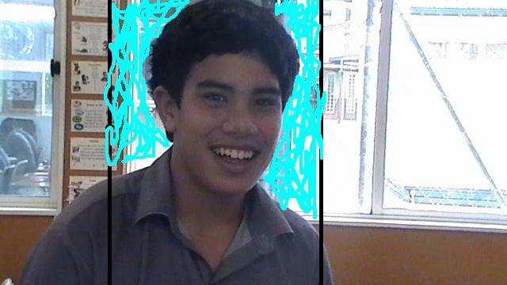

**Tapiata**

*(Tar-pee-a-tah)*

**Taniora**

*(Tar-knee-or-rah)*

**Hemopo**

*(Hair-mor-poor)*

**Porima**

*(Poor-re-mah)*

**Arana**

*(Ah-ra-nah)*

**Potaka**

*(Poor-tah-kah)*

**Kauri**

*(Co-ree)*

**Karamaena**

*(Car-ra-my-nah)*

**Kahu**

*(Car-who)*

**Hokianga**

*(Hor-key-anga)*

**Haimona**

*(High-mor-nah)*

**Tamati**

*(Tah-mah-tee)*

**Tawio**

*(Tah-wee-or)*

**Taunoa**

*(Toe-noah)*

**Winiata**

*(Wee-knee-a-tah)*

**Hamuera**

*(Ha-moo-eh-rah)*

**Ngariki**

*(Ngah-ree-kee)*

**Manaaki**

*(Ma-nah-key)*

**Pomana**

*(Poor-ma-nah)*



