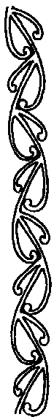
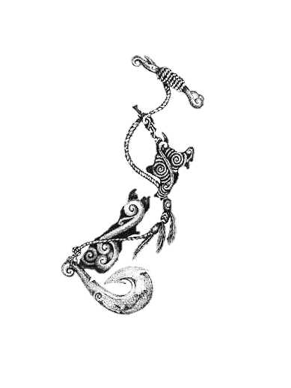
Aokautere.
Ao-kau-tere.
(Fast cloud.)
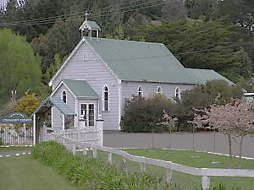

Aokautere is named after Te Aokautere, a great Rangitāne chief during the late 18th century. His parents named him Te Aokautere meaning ‘the fast cloud’ as it was the only cloud in the sky when he was born and was also a sign of good fortune.
Manawatū.
Ma-na-wa-tū.
(My heart stands still).
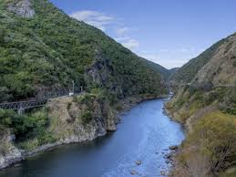

Manawatū had received its name by Haunui-a-nanaia, the great Māori explorer. As he travelled along, he came across and named river mouths including Whanganui, Whangaehu and Rangitikei according to events that befell him at the time. He came across a large, wide river mouth. In awe of the sight and in fear he might not be able to cross it, he stated "Ka tū taku manawa" (My heart stands still).

Awatapu.
A-wa-ta-pu
(Sacred river.)
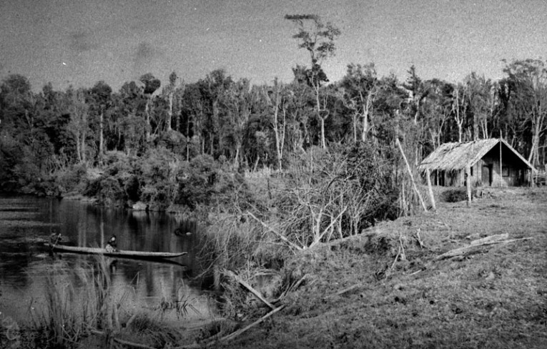

It is built upon a drained ancient lagoon, known to the local Maori as "Awatapu" meaning "Sacred River. Awatapu was a place to wash and farewell the deceased.
Between 1960-1970 the elders of the local sub-tribes up lifted the tapu (sacredness) from the area.
Rangitāne
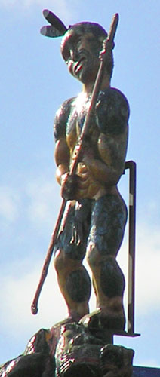
Ra-ngi-tā-ne.
(Tribe of the Manawatū)

Tautoki married Waipuna, a great-grandaughter of the great navigator Kupe, and their child was named Rangitāne (also known as Rangitānenui, Tānenui-a-rangi and Rangitānenui-a-rangi) – from whom the tribe took its name.
Awapuni.
A-wa-pu-ni.
(The Lagoon.)
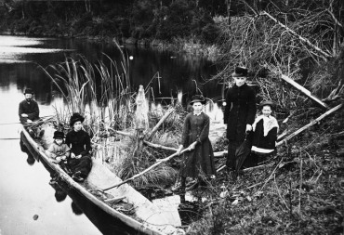

Awapuni was an ancient lagoon which was fill of resources for the local Māori both the Lagoon and the stream were an important source of eels and a bird harvest area for the Rangitāne.
Hokowhitu
Ho-ko-whi-tu
(Band/Army.)
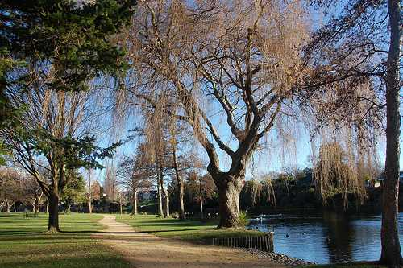

The area was filled of resources for the local Māori such as eel, rat, and other vegetation. Later it was named Te Hokowhitu-ā-Tūmatauenga meaning the Army of Tūmatauenga (God of war) where the men of the 28th Māori Battalion trained.
Te Peeti Te Aweawe
(Leader of Rangitāne tribe)
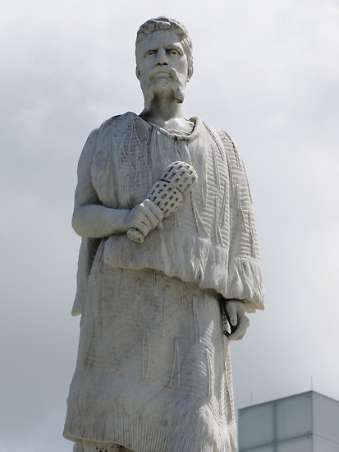
(1820-1884)

Te Peeti Te Aweawe was the son of Wiremu Kingi Te Aweawe of Rangitāne and his first wife, Hinetarake of the Whatonga tribe. He believed in protecting the people and land from other tribes trying to invade such as Waikato .In 1865 he played a major role in selling the 250,000 acre Ahu-a-Turanga block (Palmerston North district) to the Crown and encouraged European settlement there.. A marble statue of Te Peeti was erected in The Square, Palmerston North, in 1907, to commemorate his loyalty to the Crown and his friendship to the early settlers of the district.
Te Whanganui-a-Tara.
(The great harbour of Tara)
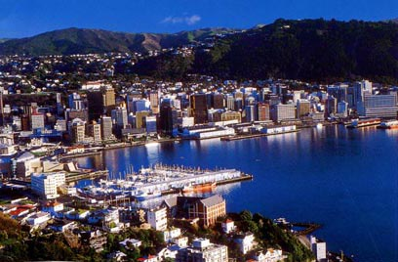
(Wellington.)

Te Whanganui- a- Tara is the Māori name for Wellington Harbour. Te Whanganui a Tara translates as the great harbour of Tara, which refers to chief Tara who Māori tradition says visited the area in the 12th century and decided to stay. According to legend, the harbour of Te Whanganui-a-Tara was created by two taniwha (sea monsters), Whataitai and Ngake.
Paraparaumu
(Pa-ra-pa-ra-u-mu)
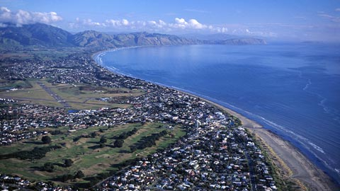

Paraparaumu means "scraps from an earth oven" in Māori 'parapara' means dirt or scraps and 'umu' means Oven.
Maunga Taranaki
(Mount Taranaki)
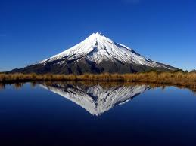

The Māori word tara means mountain peak, and Naki is thought to come from ngaki, meaning "shining", a reference to the snow-clad winter nature of the upper slopes.
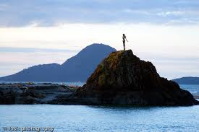
Whakatane

Wairaka, who was the daughter of Chief Toroa, boldly seized one of the paddles and paddled the waka (canoe) back to shore. As she grabbed the paddles, she shouted, ‘E! Kia Whakatane au i ahau’, (let me act the part of a man). In breach of tradition, the women paddled the canoe back to safety and from this incident, Whakatane received its name. A bronze statue of Wairaka stands on a rock at the Whakatane Heads to commemorate this act.
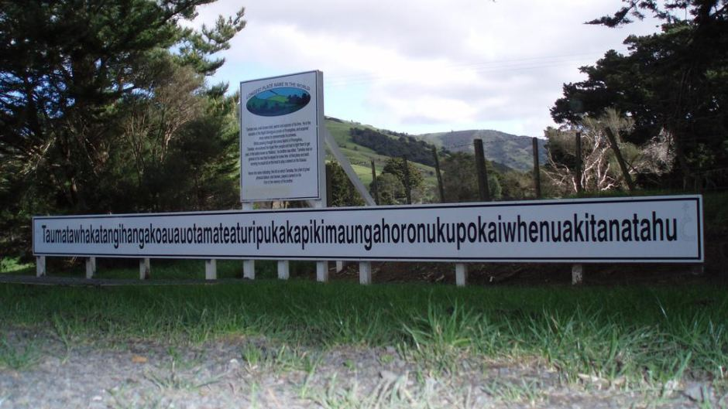
Taumatawhakatangihangakoauauotamateaturipukakapikimaungahoronukupokaiwhenuakitanatahu.

The place where Tamatea, the man with the big knees, who slid, climbed, and swallowed mountains, known as land eater played his nose flute, to his loved one.

