# Basic Components

## Resistors

Resistors are used in three ways: to limit current, with a transducer as part of a sensor subsystem and with a capacitor to introduce a time delay

## Fixed Value Resistors

The diagram shows the construction of a **carbon film** resistor:

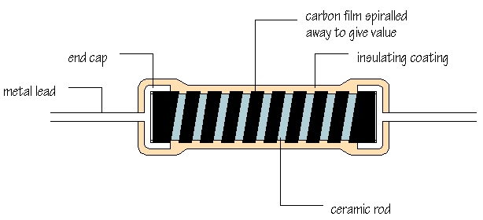

During manufacture, a thin film of carbon is deposited onto a small ceramic rod. The resistive coating is spiralled away in an automatic machine until the resistance between the two ends of the rod is as close as possible to the correct value. Metal leads and end caps are added; the resistor is covered with an insulating coating and finally painted with coloured bands to indicate the resistor value.

Carbon film resistors are cheap and easily available, with values within ±10% or ±5% of their marked or 'nominal' value. **Metal film** and **metal oxide** resistors are made in a similar way, but can be made more accurately to within ±2% or ±1% of their nominal value. There are some differences in performance between these resistor types, but none which affect their use in simple circuits.

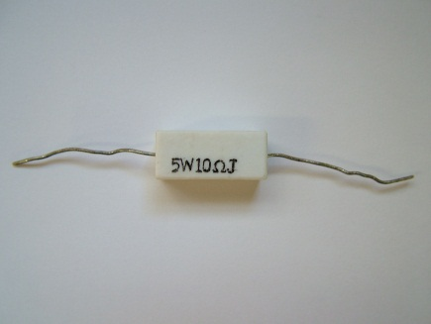

**Wire-wound** resistors are made by winding thin wire onto a ceramic rod. They can be made extremely accurately for use in multimeters, oscilloscopes and other measuring equipment. Some types of wire-wound resistors can pass large currents without overheating and are used in power supplies and other high current circuits.

The Resistor Colour Code

|  |  |
| --- | --- |
| **Number** | **Colour** |
| 0 | black |
| 1 | brown |
| 2 | red |
| 3 | orange |
| 4 | yellow |
| 5 | green |
| 6 | blue |
| 7 | violet |
| 8 | grey |
| 9 | white |

How can the value of a resistor be worked out from the colours of the bands? Each

colour represents a number according to the following scheme:

The first band on a resistor is interpreted as the FIRST DIGIT of the resistor value. For the resistor shown below, the first band is yellow, so the first digit is 4:

|  |  |
| --- | --- |
| **Tolerance** | **Colour** |
| ±1% | brown |
| ±2% | red |
| ±5% | gold |
| ±10% | silver |

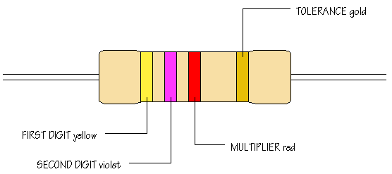

The second band gives the SECOND DIGIT. This is a violet band, making the second digit 7. The third band is called the MULTIPLIER and is not interpreted in quite the same way. The multiplier tells you how many noughts you should write after the digits you already have. A red band tells you to add 2 noughts. The value of this resistor is therefore 4 7 0 0 ohms, that is, 4,700 Ω, or 4.7kΩ. Work through this example again to confirm that you understand how to apply the colour code given by the first three bands.

The remaining band is called the TOLERANCE band. This indicates the percentage accuracy of the resistor value. Most carbon film resistors have a gold-coloured tolerance band, indicating that the actual resistance value is with + or - 5% of the nominal value. Other tolerance colours are shown to the right:

When you want to read off a resistor value, look for the tolerance band, usually gold, and hold the resistor with the tolerance band at its right hand end. Reading resistor values quickly and accurately isn't difficult, but it does take practice!

### More about colour codes

|  |  |
| --- | --- |
| E12 series10% tolerance | E24 series5% tolerance |
| 10 | 10 |
| 11 |
| 12 | 12 |
| 13 |
| 15 | 15 |
| 16 |
| 18 | 18 |
| 20 |
| 22 | 22 |
| 24 |
| 27 | 27 |
| 30 |
| 33 | 33 |
| 36 |
| 39 | 39 |
| 43 |
| 47 | 47 |
| 51 |
| 56 | 56 |
| 62 |
| 68 | 68 |
| 75 |
| 82 | 82 |
| 91 |

The colour code as explained above allows you to interpret the values of any resistor from   
100 Ω upwards. How does the code work for values less than 100 Ω? Here is the code for 12 Ω:

brown, red, black

The multiplier colour black represents the number 0 and tells you that no noughts should be added to the first two digits, representing 1 and 2.

What would be the colour code for 47 Ω? The answer is:

yellow, violet, black

Using this method for indicating values between 10 Ω and 100 Ω means that all resistor values require the same number of bands.

For values between 1 Ω and 10 Ω, the multiplier colour is changed to gold.

For example, the colours:

***brown, black, gold*** indicate a 1 Ω resistor, while the colours:  
***red, red, gold*** refer to a 2.2 Ω resistor.

Metal film resistors, manufactured to 1 or 2% tolerance, often use a code consisting of four coloured bands instead of three. The code works in the same way, with the first three bands interpreted as digits and the fourth band as the multiplier. For example, a 1 kΩ metal film resistor has the bands:

***brown, black, black, brown*** (+brown or red for tolerance)while a 56 kΩ metal film resistor has the bands: ***green, blue, black, red***

It is worth pointing out that the multiplier for metal film resistors with values from 1 kΩ upwards is brown (rather than red, as in the three colour system), while the multiplier for 10 kΩ upwards is red (instead of orange).

You are likely to use low value resistors and metal film resistors on some occasions and it is useful to know how to read their codes. However, most of the resistors you use in building electronic circuits will be carbon film types with values indicated using the three band colour code. It is this system which you should master first.

## E12 and E24 values

If you have any experience of building circuits, you will have noticed that resistors commonly have values such as 2.2 kΩ, 3.3 kΩ, or 4.7 kΩ and are not available in equally spaced values 2 kΩ, 3 kΩ, 4 kΩ, 5 kΩ and so on. Manufacturers don't produce values like these - why not? The answer is partly to do with the fact that resistors are manufactured to a percentage accuracy.

Look at the table on the right which shows the values of the ***E12 and******E24 series: - Resistors are made in multiples of these values, for example, 1.2Ω, 12 Ω, 120 Ω, 1.2 kΩ, 12 kΩ, 120 kΩ and so on.***

Consider 100 Ωand 120 Ω, adjacent values in the E12 range. 10% of 100 Ω is 10 Ω, while 10% of 120 Ωis 12 Ω. A resistor marked as 100 Ωcould have any value from 90 Ωto 110 Ω, while a resistor marked as 120 Ω might have an actual resistance from 108 Ωto 132 Ω. The ranges of possible values overlap, but only slightly.

Further up the E12 range, a resistor marked as 680 Ωmight have and actual resistance of up to 680+68=748 Ω, while a resistor marked as 820 Ω might have a resistance as low as 820-82=738 Ω. Again, the ranges of possible values just overlap.

The E12 and E24 ranges are designed to cover the entire resistance range with the minimum overlap between values. This means that, when you replace one resistor with another marked as a higher value, its actual resistance is almost certain to be larger.

From a practical point of view, all that matters is for you to know that carbon film resistors are available in multiples of the E12 and E24 values. Very often, having calculated the resistance value you want for a particular application, you will need to choose the nearest value from the E12 or E24 range.

## Variable Resistors

* 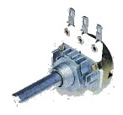Are often called potentiometers
* To obtain a fixed resistance either the outside two legs (or the two bottom legs are chosen).
* to obtain a variable resistance the middle leg is chosen with one of the outside legs (or the top leg and one of the two bottom legs)

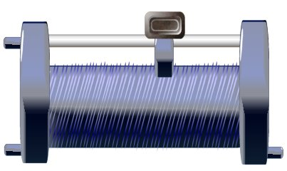

## Resistivity and the Resistance of a Wire

* 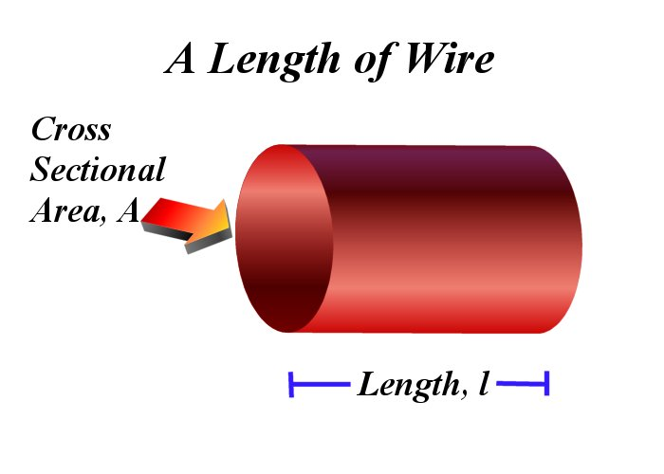The resistance of a wire is dependent upon the length of the conductor and the cross sectional area
* The resistance of a wire is proportional to the length of that wire (i.e. ). The electrons have to pass by more metal nuclei increasing the chance they will be slowed or resisted in the process.
* 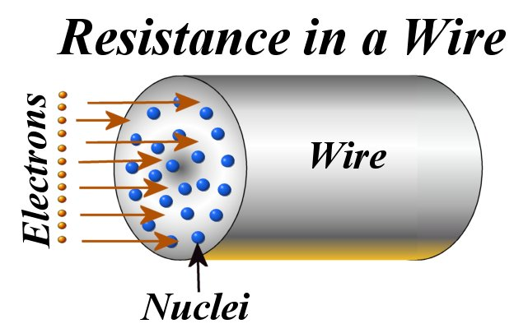The resistance of a wire is inversely proportional to the cross sectional area (i.e. ). The electrons are more likely to find an opening through which they can flow through the metal lattice the larger the cross sectional area is
* 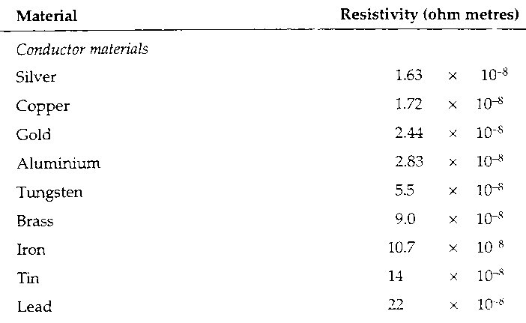The relationship between Resistance, cross sectional area and length is  or    
  where ***ρ*** is called the ***Resistivity*** of the substance.   
    
  It is a measure of the “closeness” and “attractiveness” of the metal lattice and how much it will hinder charge travelling through the lattice.
* Using the formula  we can see that if we double the cross sectional area, A, we halve the resistance of the wire. Also if we double the length of the wire we double the resistance of the wire.
* An example of the use of this formula is a strain gauge

## Example:

***How long must a piece of copper speaker wire (diameter 1 mm) be to have a resistance of 4 Ω?***

 Cross Sectional Area is given by 



***Student Name***

1. Temperature Effects on Resistance

* 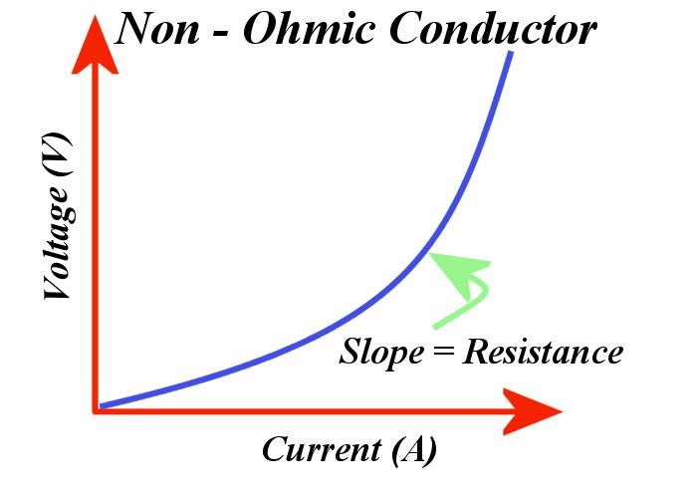Ohm’s Law is . If we plot ***V*** vs. ***I*** the slope is the Resistance, ***R***
* For a constant temperature resistor the ***voltage is directly proportional to the current***. It is said to be an ***Ohmic Conductor***
* ***Resistance is temperature dependent***
* Metals increase in resistance with increasing temperature
* 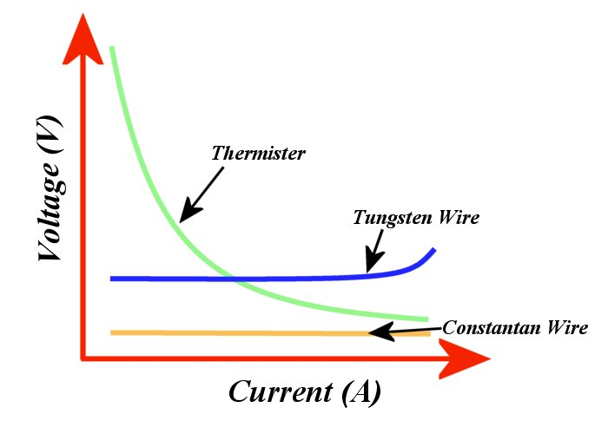If we wish to measure the resistance of something like a light bulb - we need to keep cool (at constant temperature); normally we would use a water bath (i.e. a calorimeter)
* If we increase the temperature of an Ohmic Conductor it becomes ***Non-Ohmic*** (the voltage vs. current graph is not linear)
* Examples include: Thermistor (both positive temperature coefficient (PTC) and negative temperature coefficient (NTC)), tungsten (light bulb filaments) and constantan wire

## Electronics%20-%20Capacitor%20Construction%20IICapacitors

* 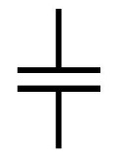Capacitors store charge

How a capacitor is constructed

Capacitor Circuit Symbol

* made from two metal plates which are separated by an insulator called a ***Dielectric***
* 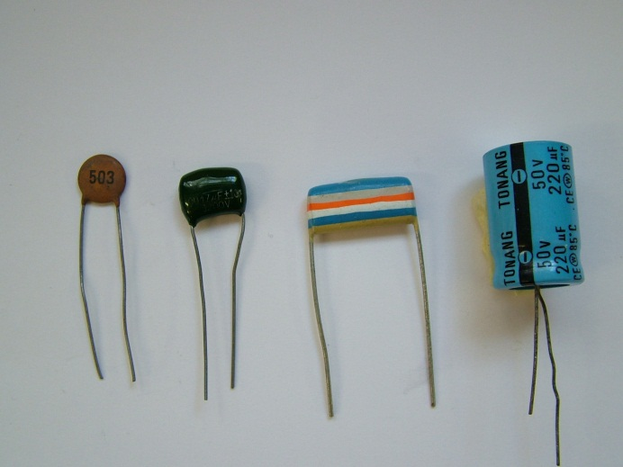Capacitance is defined as the ratio of the charge stored on the plates to the voltage applied i.e.  (where ***Q*** is measured in coulombs and ***V*** in Volts) and is measured in Farads (***F***) (Farads are large units – capacitance is normally measured in ***μ***, ***n*** or ***pF***)
* 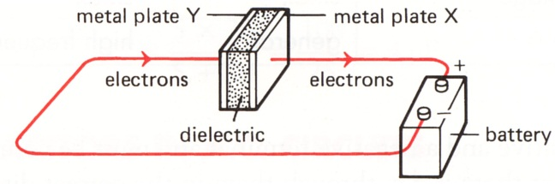The battery or cell in a circuit removes electrons from plate ***x*** (a surplus of positive charge builds up here – or a deficit of electrons)
* The battery or cell repels electrons onto the ***y*** plate (and a negative charge surplus build up here)
* The charging of these plates takes time (i.e. it’s not immediate). It stops when the potential difference (voltage) between the plates is equal and opposite to the voltage pumping charge onto the plates (the battery EMF).
* The charge remains on the plates if the battery is removed and the circuit is incomplete
* The charge will discharge if the there is no opposing voltage in a complete circuit – care is needed as this can be a substantial discharge current!
* 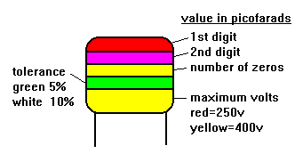The ability to hold or store charge until required in a circuit is the most important property of capacitor

## Capacitor%20-%20DiskReading Capacitors

* Some values are indicated with a colour code similar to resistors. There can be some confusion.   
  A 2200pf capacitor would have three red bands. These merge into one wide red band.
* ***More often values are marked in picofarads using three digit numbers. The first two digits are the base number and the third digit is a multiplier.   
  For example, 102 is 1000 pF*** and 104 is 100,000 pF = 100 nF = 0.1 µF
* Electrolytic “canister type” capacitors usually have their value clearly labelled on them.

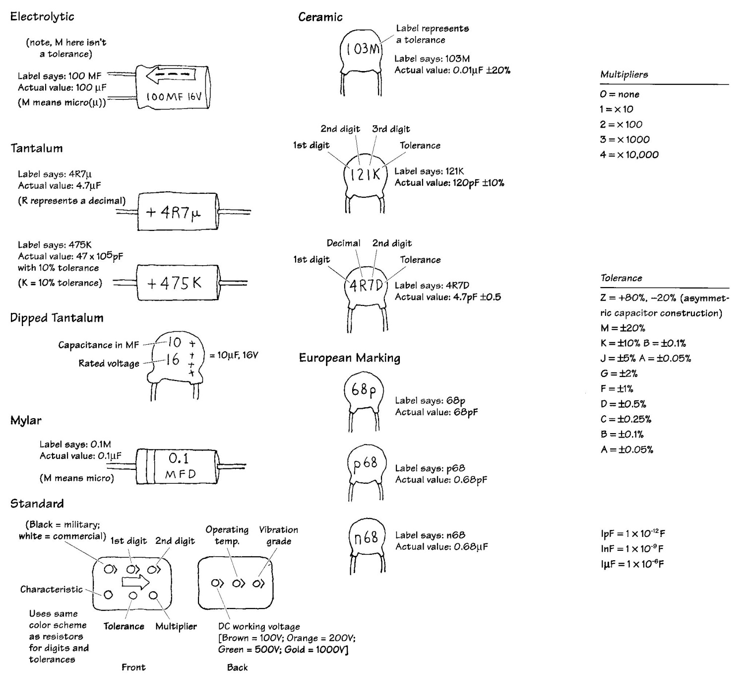

## Electronics%20-%20Capacitor%20Charging%20and%20Discharging%20GraphsCharging and Discharging Capacitors

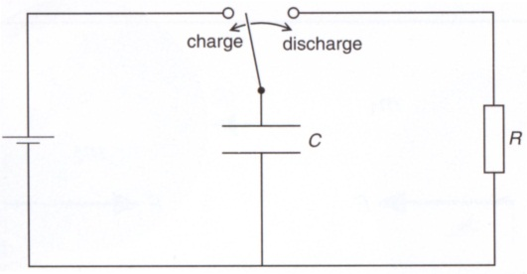***Charging a Capacitor***

* Initially there is little resistance to the power supply pumping charge onto the plates hence the current is large
* As charge builds up on the plates there is a voltage generated which tries to oppose charge being pumped onto the plates by the power supply, this means the current slows down as more and more charge is placed on the plate.
* Eventually the voltage across the plates is large enough that it equals that of the supply voltage and there is nothing to drive charge onto plates and hence no current.

***Discharging a Capacitor***

* When fully charged both plates carrying maximum charge and hence voltage
* The voltage (generated by the like charges being so close to one another) drives the charge off the plate – creating a large current in the opposite direction to that of the charging current
* As the charge leaves the plate there is less voltage and hence less driving force forcing the charge off the plates, and hence less current flow in the circuit.

## The Capacitor Time Constant τ

* The charging and discharging curves are exponential curves which follow the form  
   and  where t is the time in seconds, ***R*** is the resistance of the circuit and ***C*** is the capacitance. τ is called the time constant – it is defined as the time taken for the voltage to fall to 37% of the maximum voltage. (= 0.37).
* 

## Electric fields

* The ***electric field*** of an electric charge is the region where its presence ***can be detected by the force it exerts*** on other charges. The electric field strength, ***Ẽ***, is given by  where  is the Force and ***Q*** is the charge in coulombs
* The direction of the electric field at any point is the direction in which a small positive charge would move if placed there
* ***Coulombs Law*** states the force between two point charges is given by  where ***ε0*** = 8.85 x 10-12 C2 N-1 m-2 and is called the ***permittivity of free space*** and ***r*** is the distance between the charges and ***Q*** is the charge in coulombs (Note: the form of the equation is very similar to Newton’s Law of Gravitation)
* Using the above two equations the electric field strength is given by 
* 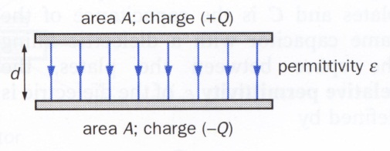The field around a sphere radiates out in all directions, becoming weaker with the distance away from the sphere
* Between two parallel oppositely charged plates, the field is uniform (of constant strength and direction) between the plates – however it buckles out at the edges

## The Electric Field of a Capacitor

* A capacitor stores electrical potential energy by the means of the separation of charge
* 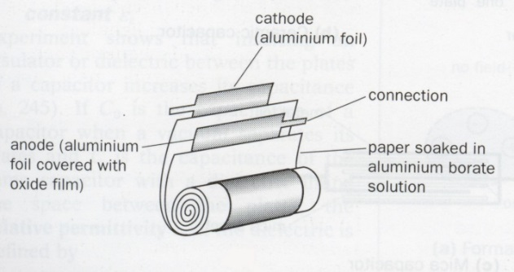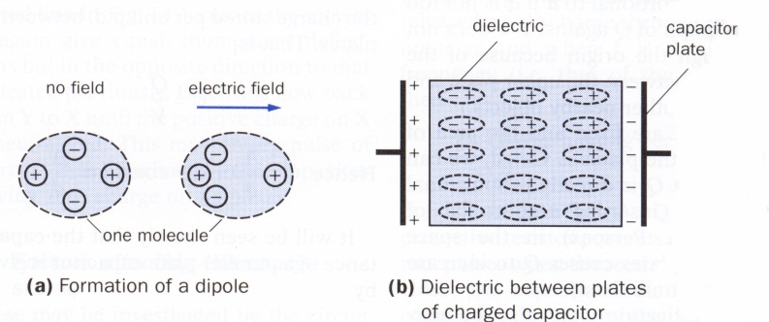Capacitors are two metal plates separated by a distance, ***d***, with a surface area, ***A***. They usually have some sort of material between the plates which increases the charge separation affected – this material is called the ***dielectric***. Often these two metal plates and the dielectric are rolled into a cylinder
* A battery acts as “electron pump”, taking electrons from the positive plate and depositing them on the negative plate. This creates a charge differential across the plates, which in turn creates an electric field

## Electric Field Strength

* The force experienced by a charge will vary according to   
     
  or  where ***Q*** is the amount of charge on the plates; ***Ẽ*** is the electric field strength.
* The work done to shift a positive charge from the positive plate through to the negative plate is given by  as   
  The definition of voltage is  where ***W*** = Work (or Energy in Joules)  
  ⇨  from above   
  or  where ***V*** is the voltage  
   and ***d*** is the distance between the plates
* Capacitors%20-%20Charge%20vs%20Voltage%20Graph%20(WMF)The amount of charge build up on the plates is directly proportional to the ***EMF*** or voltage driving electrons off the positive plate and onto the negative plate. Hence. A graph of charge on the plate versus voltage is a straight line graph through the origin. The slope of this graph is a constant for a particular capacitor and is called the ***Capacitance***. i.e. 
* Capacitance has the unit ***Farad (F)*** – this is a very large unit. It is normally μ, n or pF.
* If we look carefully at this graph, the area under the graph has the units    
    
  hence Electrical Potential Energy Stored in the Plates = Area under the Graph  
    
  i.e. 

## Capacitors%20-%20Dielectric%20ConstantCapacitor Construction Formula

* The capacitor’s effect is enhanced by inserting a dielectric (plastic or paper etc) between the two plates. This enhances the electric field which and turn creates a larger capacitance.
* The capacitance of the plate is proportional to the surface area of each plate i.e. 
* The capacitance is inversely proportional to the distance between the plates (as the electric field decreases with increasing distance) i.e. 
* Ideally  where ***ε0*** is the ***absolute to permittivity of free space =8.842 x 10-12 F m-1***. This is then corrected to take account of the effect of the dielectric  where ***εr*** is called the ***dielectric constant*** and is a constant for a particular dielectric. It is the ***ratio of the capacitance with the dielectric to the capacitance with just an air gap*** i.e. 

The Capacitor Circuit Symbol. A **+** sign is added to one of the plates to indicate an electrolytic capacitor

A tuneable capacitor

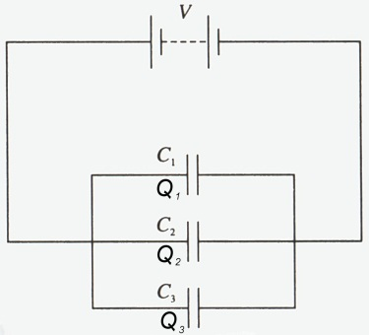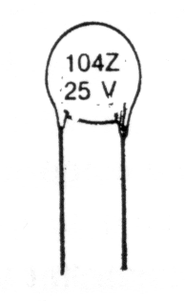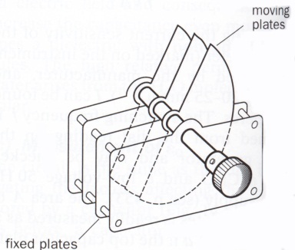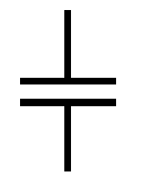

A disk capacitor

The capacitor symbol.

A + sign is added to one of the plates to indicate an electrolytic capacitor

## Capacitors in Parallel

* Combining capacitors in parallel increases the equivalent capacitance since it increases the effective area for storing charge.
* The total charge stored is given by  
    and as   
    and as the voltage is the same because they are in parallel  
   

## Electronics%20-%20Capacitors%20in%20SeriesCapacitors in Series

* Effectively only a charge Q is stored on each plate
*  and   
  ⇨  
  ⇨

## Electronics%20-%20Capacitor%20ElectrolyticElectronics%20-%20Capacitors%20-%20How%20Dielectrics%20WorkElectrolytic Capacitors

* These capacitors are polar (directional)
* They have a directional dielectric which enhances the amount of charge able to be stored (but only in one direction)
* If these capacitors are not placed the right way around the capacitor can breakdown (and sometimes shrapnel goes everywhere)

## Semiconductors

* these have a conductivity between that of good conductors and good insulator's

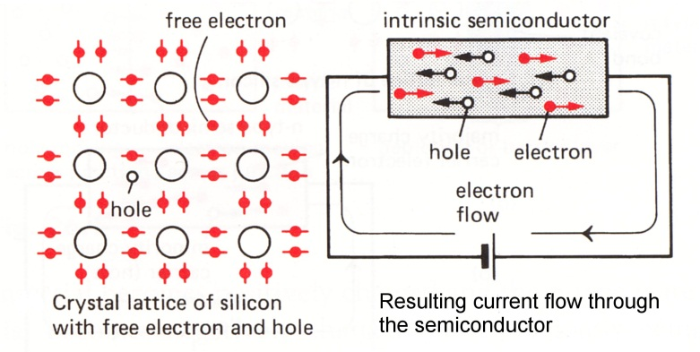 ***Ideal silicon (at 0 Kelvin) Silicon at room temperature***

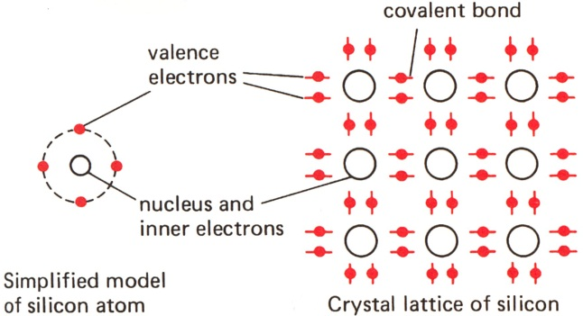

***Normal thermal vibrations of the crystal lattice***

Vibrations allow some bonds to break setting "free" some valence electrons.

At deficit of negative charge remains called a ***hole***.

Electrons flow by hopping from one hole to another allowing conduction to occur

***Silicon atoms***

each atoms has four valence electrons which it shares with its neighbours. It is very stable and a good insulator

## P & N type semiconductors

* For this conduction to be useful it needs to be increased so that more current can flow
* this is done by ***"Doping" the silicon - adding tiny controlled amounts of impurities***
* these purity atoms are of the same size the silicon atoms so they can fit in the crystal lattice
* there are two types; ***N-type*** and ***P-type***

***N-type***

* here the lattice is doped with an atom with five valence electrons i.e. phosphorus
* the majority charge carriers are electrons (negative) hence its name N-type

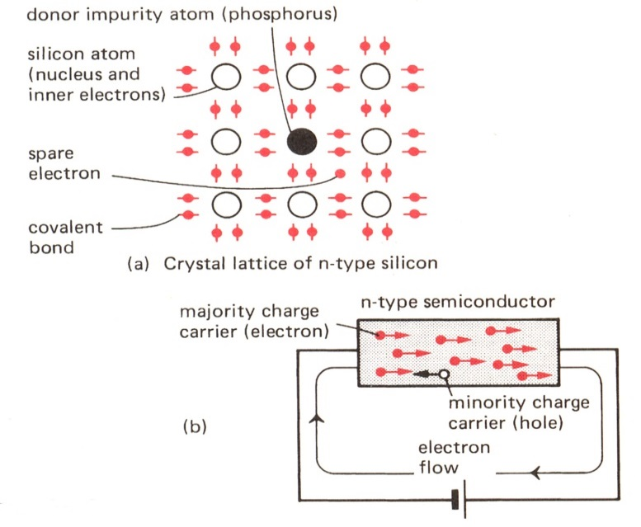

***N-Type Semi conduction***

***P-type***

* here the lattice is doped with a symbol with three valence electrons i.e. boron
* 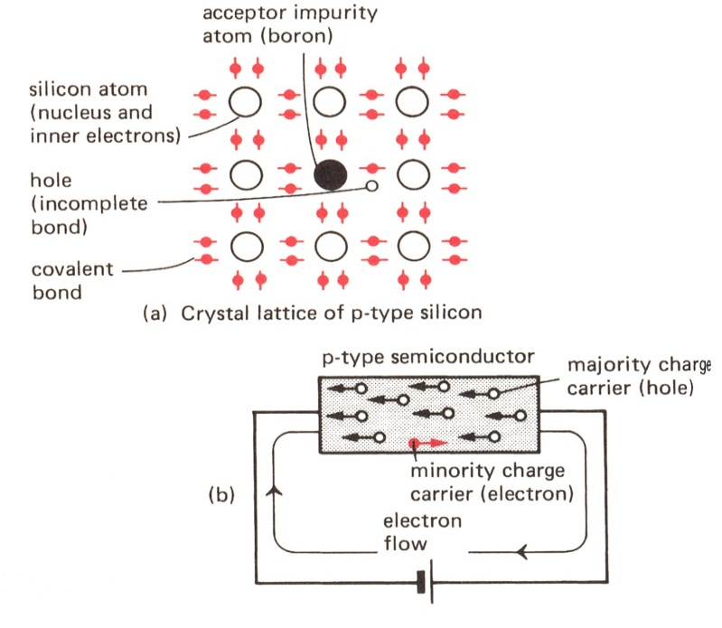the majority charge carriers are holes (‘positive”) hence the term P-type

***P-Type Semi conduction***

## The P-N Junction

* When a P and an N type semiconductor are placed together electrons from the N-Type semi conductor recombine with holes from the P-type. This creates a ***depletion zone***.

***P-N Junction and the depletion zone***

* For electrons to cross this depletion zone energy (in the form of voltage) is required (normally about 0.6 V)
* 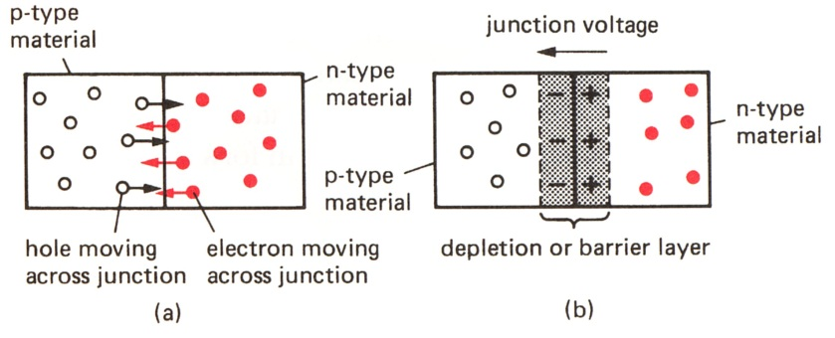if a cell or battery is connected so that the positive terminal of the cell connects to the N-type semi conductor, then the depletion zone widens and it becomes “***impossible***” for electrons to jump this depletion zone without a large amount of energy gained from a high supply voltage. It is said that the P-N junction it is ***reverse biased***.

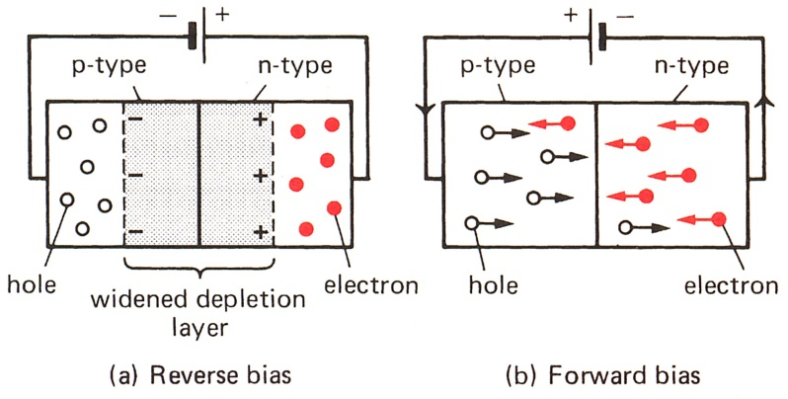

* if a cell is connected so that the positive terminal connects to the P-Type semi-conductor then the depletion zone shrinks and conduction is enhanced. It is said that the P-N junction it is ***forward biased***. A large amount of current will flow for relatively little amount of voltage increase.

## The Diode

* 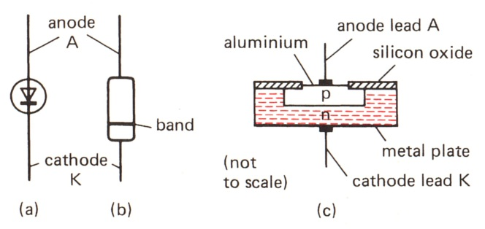This is the practical use of P-N junctions
* A diode allows current flow and only one direction
* The direction of conventional current flow is indicated on the diode symbol by the arrow.

***Current flow in a diode – note milli and micro amp scales on the y axis***

* 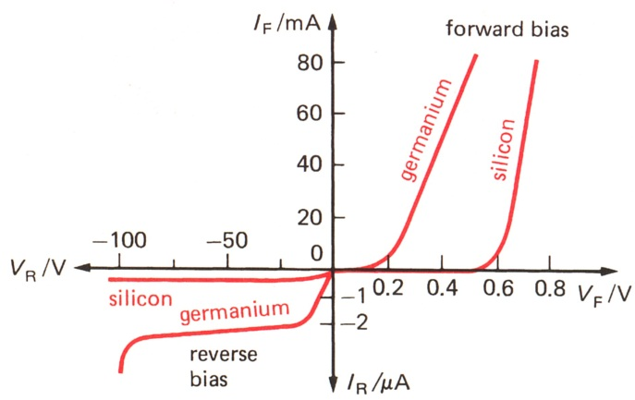The “negative end” of the diode is indicated by the black band on the diode casing. This corresponds to the dash in the diode circuit symbol
* ***CAUTION: Diodes must be connected in series with a ballast resistor or they will blow***.
* Hole-electron recombination produces energy - normally in the form of heat
* Types of diodes
  + Signal - used to the detection of low voltage/current signals like a radio and TV receivers
  + Power - used in "main load" circuits
* Diode uses include
  + prevention of damage to circuits by reversed power supply leads
  + Rectification of AC current

### Rectification of AC current/voltage

* AC current needs to be converted into D.C. current to be used in household appliances and computers
* Diodes provide a convenient way to converted AC to D.C.
* A single diode will allow current flow in only one direction hence in the second half of an AC cycle (the negative part) no current is able to flow. This is called ***half wave rectification*** has half of the wave is “made right”

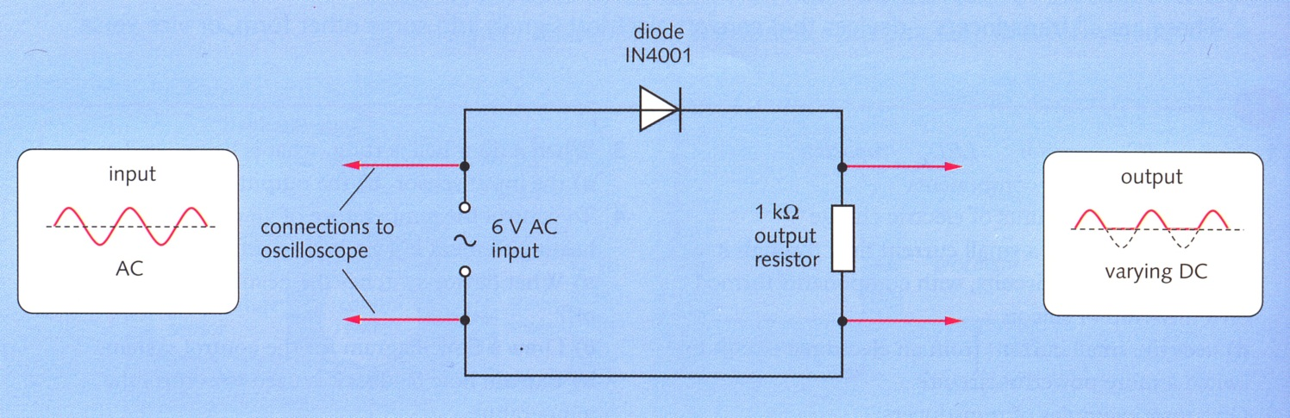

* However this wastes half the power of an AC cycle
* ***Full wave rectification*** utilises a diode bridge arrangement which insures that no matter which direction the current enters the bridge it always leaves the same way

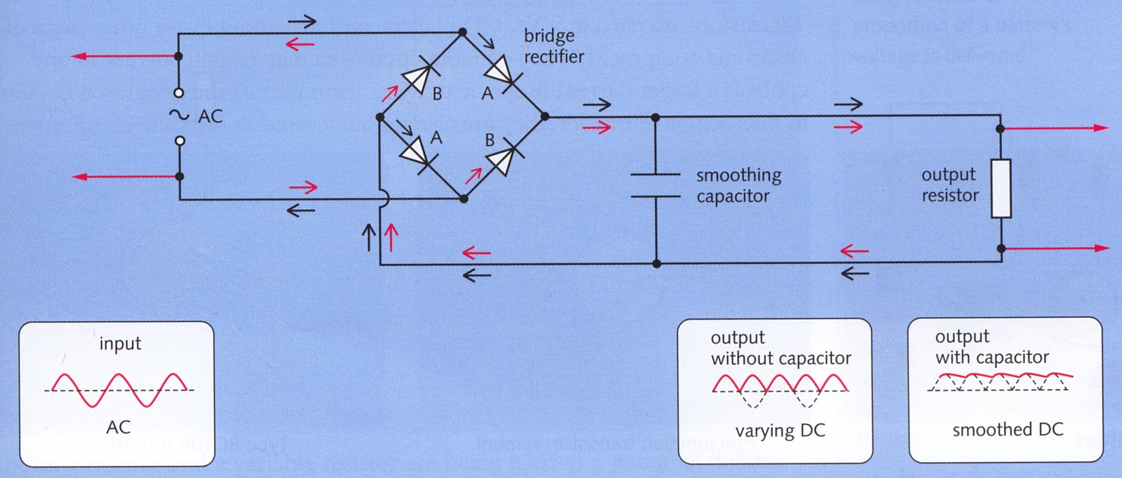

* The resulting waveform oscillates between 0 V and the maximum voltage.
* To smooth out the bumps a ***smoothing capacitor*** is inserted. These take time to charge and discharge and will discharge when the current drops “smoothing” out any current fluctuations. The larger the capacitor is smoother D.C. voltage/current obtained

### Diodes as temperature measurers

* As a semiconductors resistance decreases with increasing temperature we can use this property to measure temperature
* Voltage across the semiconductor will change depending on the temperature
* A plot of voltage vs. temperature will produce a calibration graph from which we can interpolate to find the temperature in an unknown situation.

### Zener Diodes

A Zener diode is a device that acts as a typical PN junction diode when it is forward biased, but it also has the ability to conduct in the reverse biased direction when a specific breakdown voltage (***VB***) is reached. Zener Diodes have typical breakdown voltages between a few volts and a few hundred volts.

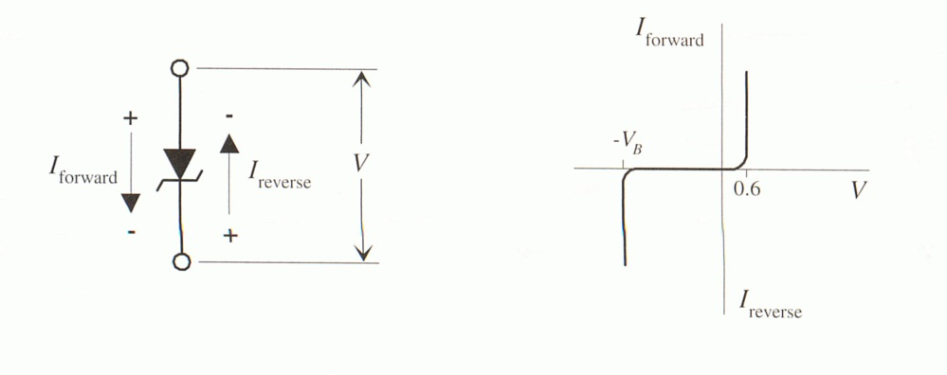The graph shows a typical breakdown curve for a Zener Diode. It shows that the Zener keeps at the same voltage for large increases in current when it has reached its breakdown voltage. This allows the Zener to “dictate” the voltage in that part of the circuit. This is the most normal use for a Zener (controlling voltage).

The following diagram shows the other common uses

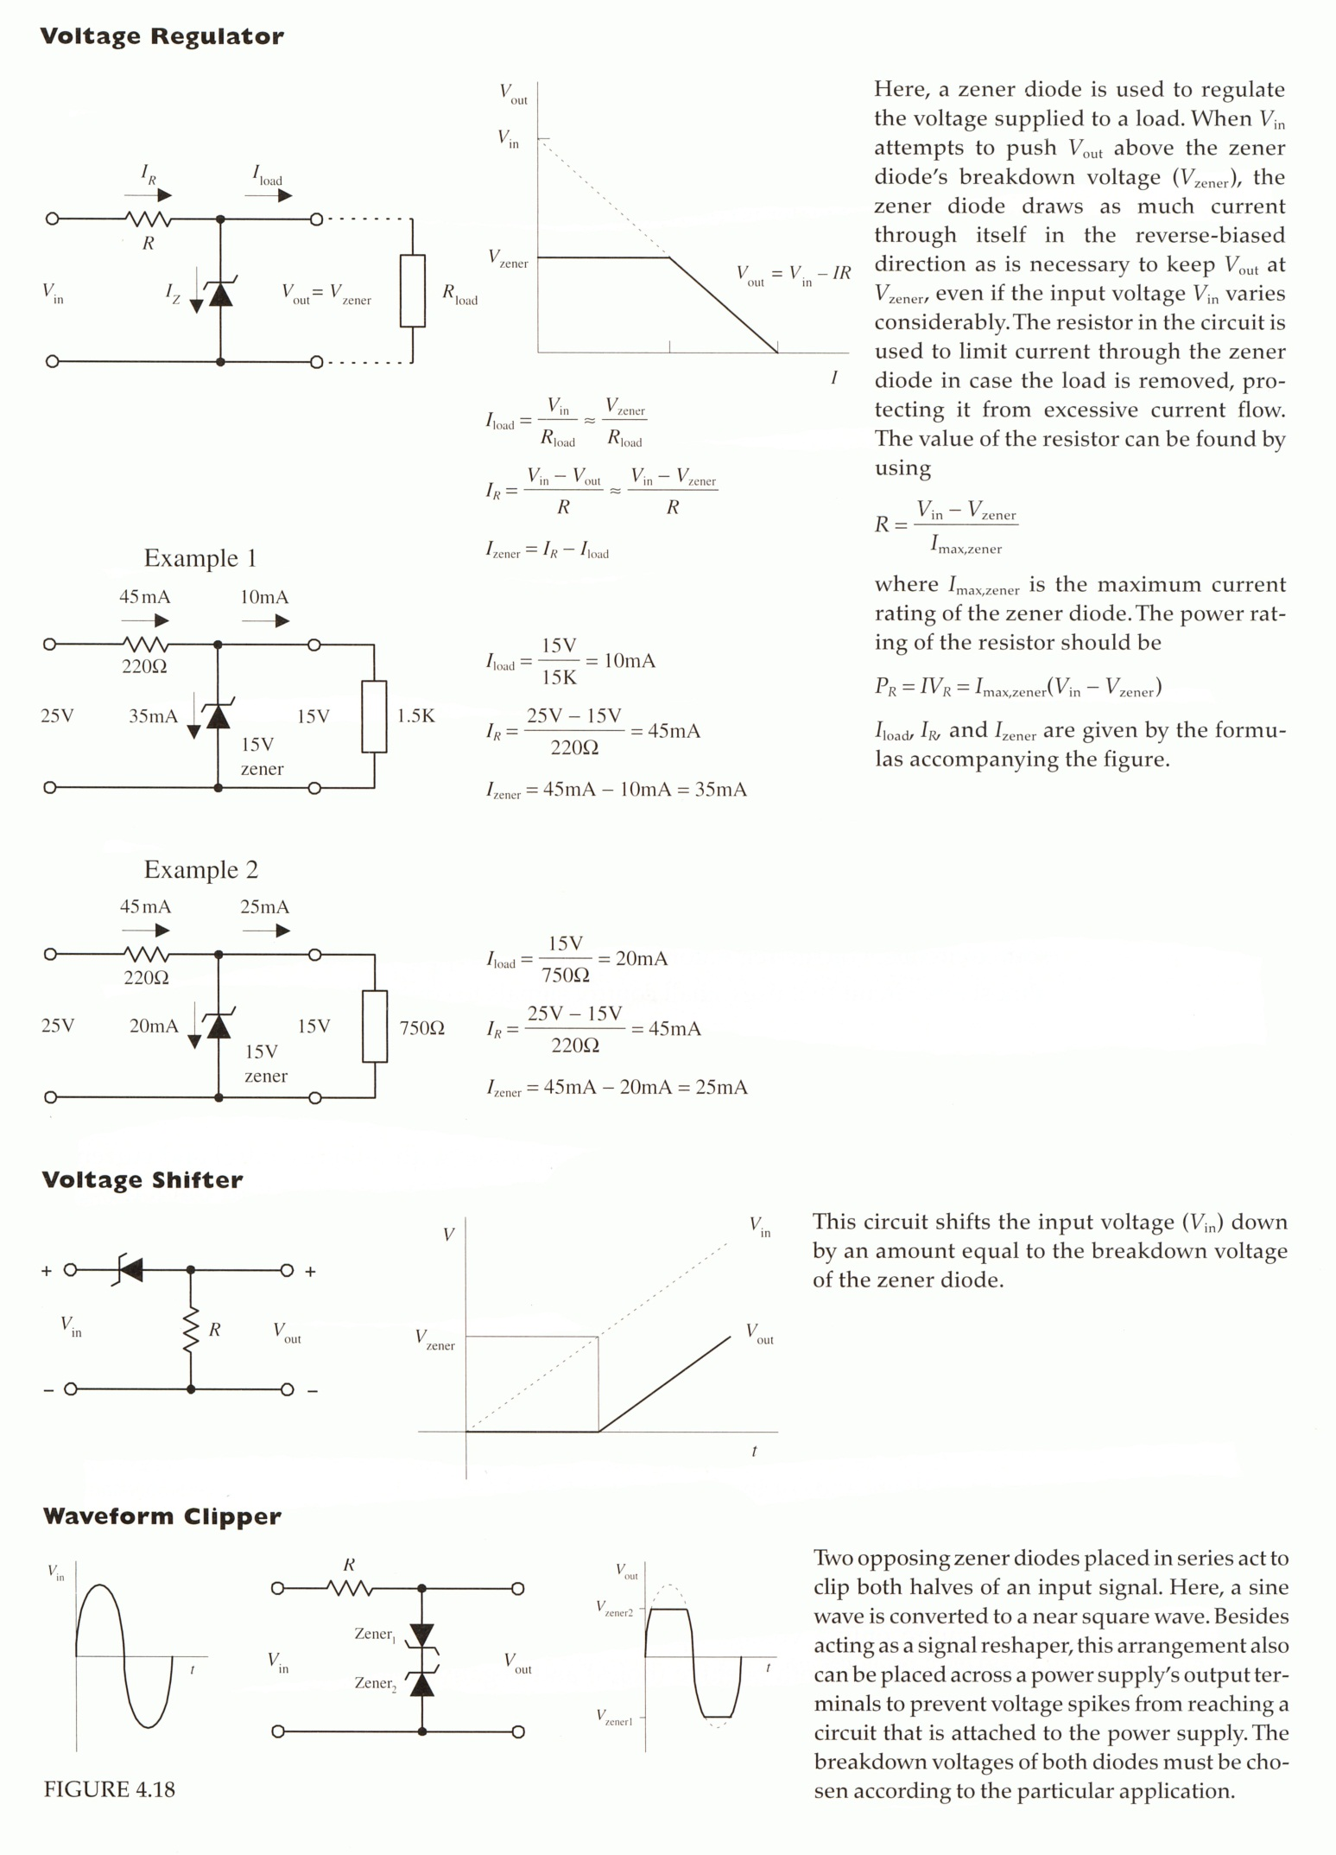

## Diode Characteristic Curve Practical.

The Diode is a semi-conductor device that has some unusual properties. In this practical you will investigate the Current Voltage Characteristics of a standard 1N4001 Power Diode.

***Student Name:***

1. Set up the following circuit, making sure the diode is forward biased (the end with the silver band is closest to the negative terminal of the power pack).

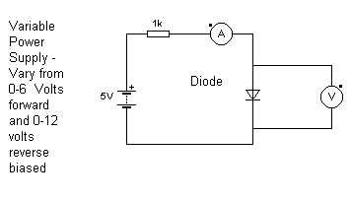

1. Set the Supply Voltage (the voltage on the Power Pack) to the values indicated in the table as ***VS***. Using the multimeters in the positions shown record the voltage across the diode and the current flowing in the circuit using the data table.

|  |  |  |  |  |  |  |  |
| --- | --- | --- | --- | --- | --- | --- | --- |
| VS (V) | 0.0 | 0.5 | 1.0 | 1.5 | 2.0 | 2.5 | 3.0 |
| VF (V) |  |  |  |  |  |  |  |
| IF (mA) |  |  |  |  |  |  |  |

|  |  |  |  |  |  |  |
| --- | --- | --- | --- | --- | --- | --- |
| VS (V) | 3.5 | 4.0 | 4.5 | 5.0 | 5.5 | 6.0 |
| VF (V) |  |  |  |  |  |  |
| IF (mA) |  |  |  |  |  |  |

### Rotate the diode into the reverse biased position in the above circuit and complete the following data table.

|  |  |  |  |  |  |  |  |
| --- | --- | --- | --- | --- | --- | --- | --- |
| VS (V) | 0.0 | -1.0 | -2.0 | -3.0 | -4.0 | -5.0 | -6.0 |
| VR (V) |  |  |  |  |  |  |  |
| IR (μA) |  |  |  |  |  |  |  |

|  |  |  |  |  |  |  |
| --- | --- | --- | --- | --- | --- | --- |
| VS (V) | -7.0 | -8.0 | -9.0 | -10.0 | -11.0 | -12.0 |
| VR (V) |  |  |  |  |  |  |
| IR (μA) |  |  |  |  |  |  |

1. Plot the forward biased current ***IF*** (*y axis*) versus the forward biased voltage ***VF*** (*x axis*) using the first quadrant of the following graph paper.
2. Using an appropriate change of scale plot the reverse biased current versus the reversed biased voltage in the 3rd quadrant of your graph.



1. What is the barrier potential in the forward biased position (the voltage which allows free current movement – the diode characteristic curve changes the most rapidly (i.e. the knee in the curve))?
2. What is the barrier potential in the reverse biased position?
3. What is the physical reason for the forward and reverse biased barrier potentials?

## Zener Diode Characteristic Curve Practical.

***Student Name:***

The Zener Diode is a semi-conductor device that breaks down at a specific voltage when reverse biased. This allows current to flow unimpeded at this voltage – creating an ideal way to control the voltage in a circuit. In this practical you will investigate the Current Voltage Characteristics of standard 6V2 Zener Diode.

1. Set up the following circuit, making sure the zener diode is forward biased (the end with the silver band is closest to the negative terminal of the power pack).



|  |  |  |  |  |  |  |  |
| --- | --- | --- | --- | --- | --- | --- | --- |
| VS (V) | 0.0 | 0.5 | 1.0 | 1.5 | 2.0 | 2.5 | 3.0 |
| VF (V) |  |  |  |  |  |  |  |
| IF (mA) |  |  |  |  |  |  |  |

|  |  |  |  |  |  |  |  |
| --- | --- | --- | --- | --- | --- | --- | --- |
| VS (V) | 3.5 | 4.0 | 4.5 | 5.0 | 5.5 | 6.0 | 6.5 |
| VF (V) |  |  |  |  |  |  |  |
| IF (mA) |  |  |  |  |  |  |  |

1. Set the Supply Voltage (the voltage on the Power Pack) to the values indicated in the table as ***VS***. Using the multimeters in the positions shown record the voltage across the diode and the current flowing in the circuit using the data table.

### Rotate the diode into the reverse biased position in the above circuit and complete the following data table.

|  |  |  |  |  |  |  |  |
| --- | --- | --- | --- | --- | --- | --- | --- |
| VS (V) | 0.0 | -2.0 | -4.0 | -4.5 | -5.0 | -5.5 | -6.0 |
| VR (V) |  |  |  |  |  |  |  |
| IR (μA) |  |  |  |  |  |  |  |

|  |  |  |  |  |  |  |
| --- | --- | --- | --- | --- | --- | --- |
| VS (V) | -6.5 | -7.0 | -7.5 | -8.0 | -9.0 | -10.0 |
| VR (V) |  |  |  |  |  |  |
| IR (μA) |  |  |  |  |  |  |

1. Plot the forward biased current ***IF*** (*y axis*) versus the forward biased voltage ***VF*** (*x axis*) using the first quadrant of the following graph paper.
2. Using an appropriate change of scale plot the reverse biased current versus the reversed biased voltage in the 3rd quadrant of your graph.



1. What is the breakdown voltage of the Zener diode?
2. What potential uses could be found for the reverse breakdown voltage

## thermistor

**The Transistor**

* 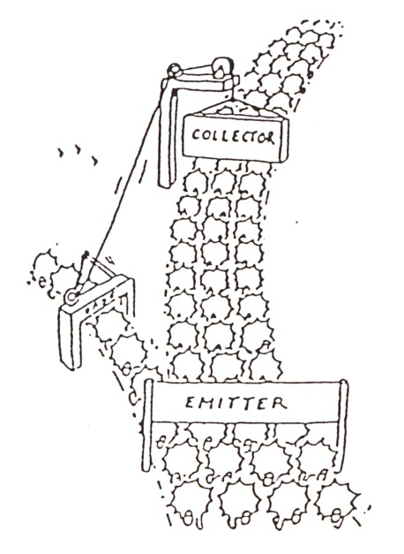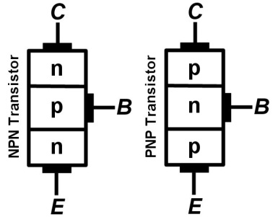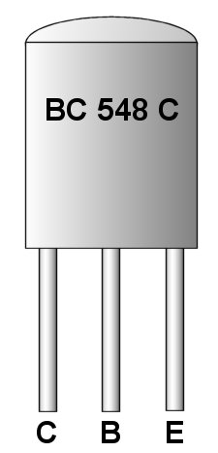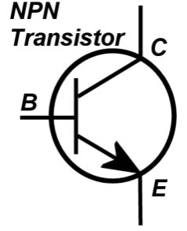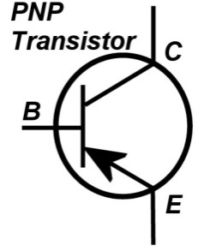A very lightly doped P or N type material called the ***Base*** (***B***) is sandwiched between two heavily doped slices of the opposite type of material called the ***Collector*** (***C***) and the ***Emitter*** (***E***)

The collector “gate” is closed until current flows through the base “gate”

Transistor semiconductor layout

Transistor physical layout and leg orientation

The Transistor NPN and PNP circuit symbol

**Basic Functioning**

* The three legs allow transistors to connect to two separate parts of a circuit
* ***There are two current paths through a transistor  
   A) through the base-emitter pathway  
   B) when A) is happening the collector-emitter pathway is “opened” and a much larger current can flow through the collector-emitter pathway***
* This allows the current one part of the circuit to control what happens in another part

## Example

* With switch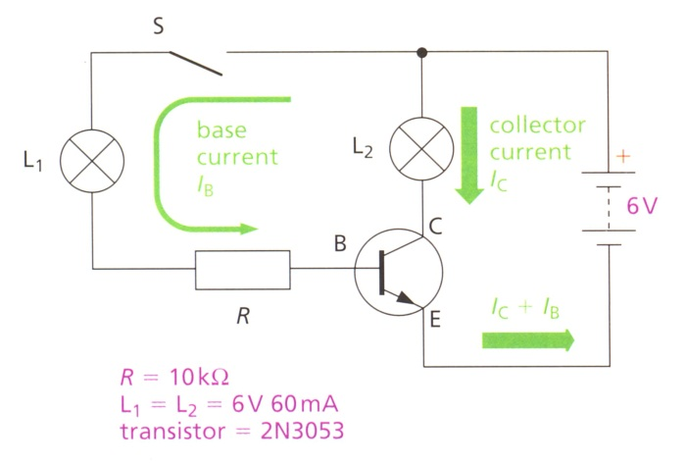 S is open - no current can flow through the input circuit and hence no current through the base terminal
* As a result of no current is allowed to flow through the collector-emitter terminals (and hence no current through the output circuit)
* If switch S is closed - the flow of even a small amount of current through the base allows a large flow of current round the output circuit
* As the “openness” of the collector-emitter pathway is determined by the signal into the base-emitter pathway the output signal mimics the input signal
* Hence a transistor can be used as an ***electronic switch*** (which has no moving parts!) or as an ***amplifier*** of the Input circuits (signal into the Base) “ input signal”

## Electronics%20-%20Transistor%20Action%20ExampleExample

***Initially a finger is placed on the LDR, blocking off the light. The voltage across the LDR is then 4.5 V and the bulb does not light***

1. ***Calculate the voltage VR across the resistor, showing the working clearly.*** 
2. ***Calculate the current IR through the resistor of resistance R = 876 Ω, showing your working clearly.*** 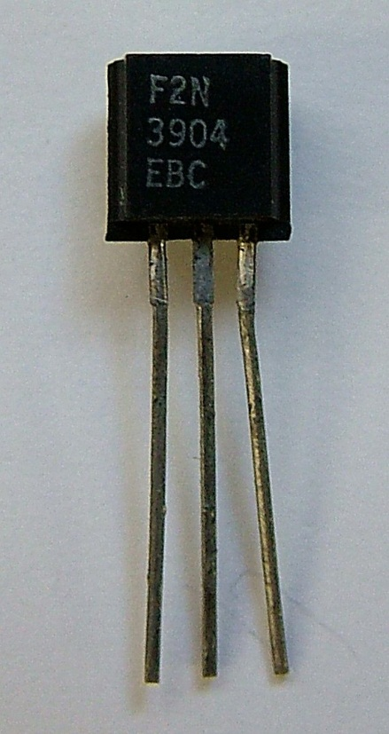

***The finger is removed from the LDR. The voltage VLDR across the LDR is now 2.5 V and the bulb does light***

1. ***Calculate the voltage VR across the resistor, showing your working clearly***  
    
2. ***Calculate the current IR through the resistor, of resistance R = 876 Ω showing your working clearly***  
    

## Transistor Characteristic Curve Practical

***Student Name:***

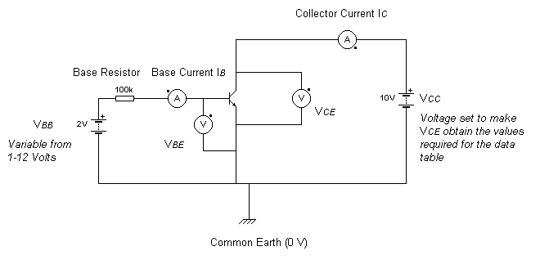

1. If you had to set the above circuit up on a breadboard how would you do it? Show how in the box below.

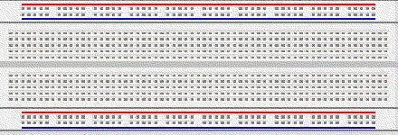  


1. Set up this circuit on your breadboard.
2. Complete the following data table for the specified values of *VBB* and *VCE* to obtain the base current and the collector currents at these voltages

|  |  |  |  |  |  |  |  |
| --- | --- | --- | --- | --- | --- | --- | --- |
|  | | ***VCE* in Volts** | | | | | |
| ***VBB*(V)** | ***IB* (μA)** | **0.10** | **0.50** | **1.0** | **5.0** | **10** | **20** |
| 1 |  |  |  |  |  |  |  | ***IC* in mA** |
| 2 |  |  |  |  |  |  |  |
| 3 |  |  |  |  |  |  |  |
| 4 |  |  |  |  |  |  |  |
| 5 |  |  |  |  |  |  |  |

1. Plot the five curves obtained on the Graph 1 on the next page (Plot *IC* vs. *VCE* and label each curve with its appropriate value of base current (*IB*)).  
   (***You may wish to use different coloured pens for each curve***)  
     
   What does the active region of the collector characteristics tell you about the dependency of the collector current (*IC*) on base current (*IB*)? What about on collector emitter voltage (*VCE*)?
2. ***Using the same apparatus*** set *VCC* at 10 V and run the analysis again for each value of the base emitter voltage (*VBE*) and the collector current (*IC*). Note that the collector current is approximately equal to the emitter current.

|  |  |  |  |
| --- | --- | --- | --- |
| ***VBB* (V)** | ***IB* (μA)** | ***VBE* (V)** | ***IC* ≈ *IE* (mA)** |
| 2 |  |  |  |
| 4 |  |  |  |
| 6 |  |  |  |
| 8 |  |  |  |
| 10 |  |  |  |
| 12 |  |  |  |

1. From the above table plot the *IB* vs. *VBE* data on the Graph 2.. Then draw the best-fit curve.  
     
   What does the base characteristic curve tell you about the base-emitter junction compared to a forward biased diode?
2. Using the second data table calculate the current gain  at *VBB* = 2 V and at *VBB* = 12 V. Is the Current gain constant or does it vary when the collector current changes? Is the variation large or small?



***Graph 1:- IC  vs. VCE . Label each curve with its appropriate value of base current (IB)***

***Graph 2:- IB vs. VBE***

## Transistor Saturation Curves Practical

***Student Name:***

1. Set up the following circuit on your breadboard



1. Complete the following data table. Set the following value of *VBB*, record the corresponding value of *IB* in the data table. Set the value of *VCE* found at the top of the table, then obtain the corresponding value of *IC* from your multi-meters and insert this in the appropriate table entry (under the value of *VCE* and across from the correct value of *VBB*).

|  |  |  |  |  |  |  |  |  |
| --- | --- | --- | --- | --- | --- | --- | --- | --- |
|  |  | **Set** ***VCE* to these values in volts** | | | | | | |
|  |  | **0.10** | **0.20** | **0.50** | **1.0** | **2.0** | **5.0** | **10** |
| ***VBB* (V)** | ***IB* (μA)** | **Value of *IC* (mA) corresponding to the above value of *VCE*** | | | | | | |
| 0.0 |  |  |  |  |  |  |  |  |
| 2.0 |  |  |  |  |  |  |  |  |
| 4.0 |  |  |  |  |  |  |  |  |
| 6.0 |  |  |  |  |  |  |  |  |
| 8.0 |  |  |  |  |  |  |  |  |

➊ Set ***VBB*** to these values then set the appropriate values of ***VCE***

➌ Record ***IB*** and ***IC***

➋ Set ***VCE*** to these values after setting ***VBB***

1. Using the graph paper on the next page plot the five curves obtained on one set of axes (plot *IC* on the vertical axis and *VCE* on the horizontal axis) Label each curve with the appropriate value of the base current (*IB*) for identification (It may help to plot the best fit line through each curve in a different colour/style and you may rotate the orientation of the axes for convenience in plotting).



1. What do the graphs above tell you about the dependency of the collector current (*IC*) on the base current (I*B*)?
2. How does the collector current, *IC*, depend on the collector emitter voltage, *VCE*?

## Semi-conductor transducers

## Thermistors

* Thermistors use the temperature property of semiconductors

The thermistor circuit symbol

* Thermistors come in two types ***NTC*** and ***PTC***

***NTC Thermistors (Negative Temperature Coefficient)***

* resistance decreases as the temperature increases
* These are useful for controlling start-up currents (when devices cold more current flows and could blow the circuit. The solution is to insert a NTC thermistor which has a high resistance at a low temperature but which lowers its resistance as the device warms up)

***PTC Thermistors (Positive Temperature Coefficient)***

* resistance increases as the temperature increases
* These are useful for heat damage protection in circuits such as amplifiers. As amplifiers warm up more and more current is able to flow which causes the amplifier to warm up more which repeats the cycle. A PTC Thermistor stops this cycle by increasing the resistance hence decreasing the current as the amplifier warms up

## Light Emitting Diode

The LED circuit symbol

* 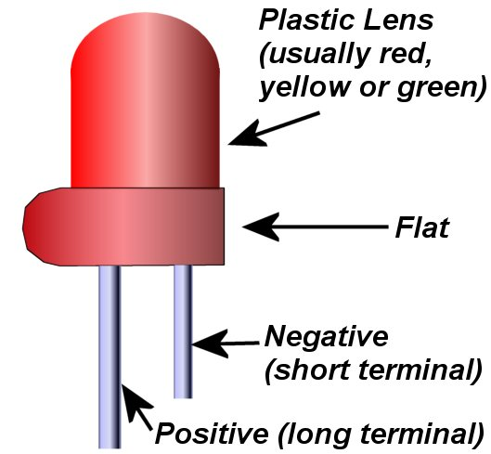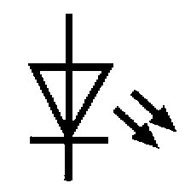The semiconductor material is ***gallium arsenide phosphide***
* Hole/electron recombination in semiconductors releases energy. This is normally released in the form of heat
* In LEDs some of this energy is released as light (photons of energy)
* A LED acts like a normal diode accept it glows it is forward biased
* Useful as an indicator of voltage/current direction

## Light Dependent Resistor

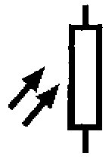

The LDR circuit symbol

* 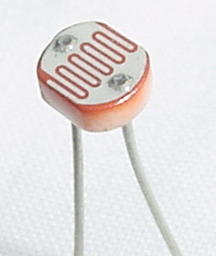Made usually of cadmium sulphide
* Use the reverse effect of LEDs
* Light supplies energy to set free charge carriers from the atoms of the semiconductor material hence increasing its conductivity (and reducing its resistance)
* 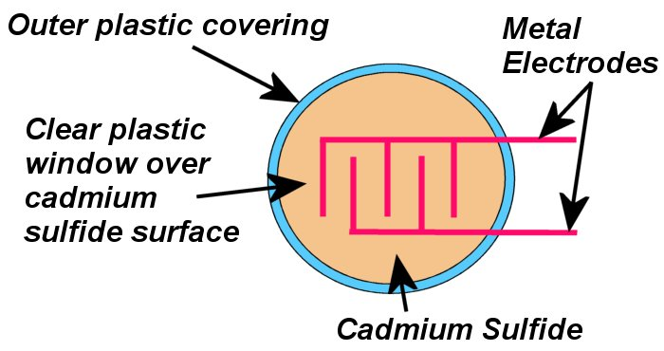Typically it has a resistance values ***Dark Light***  
   10 MΩ 1 kΩ

## Relay

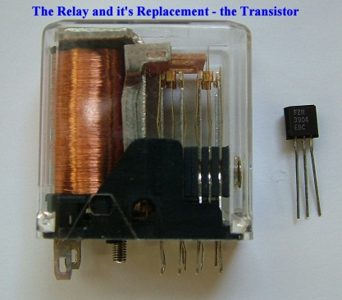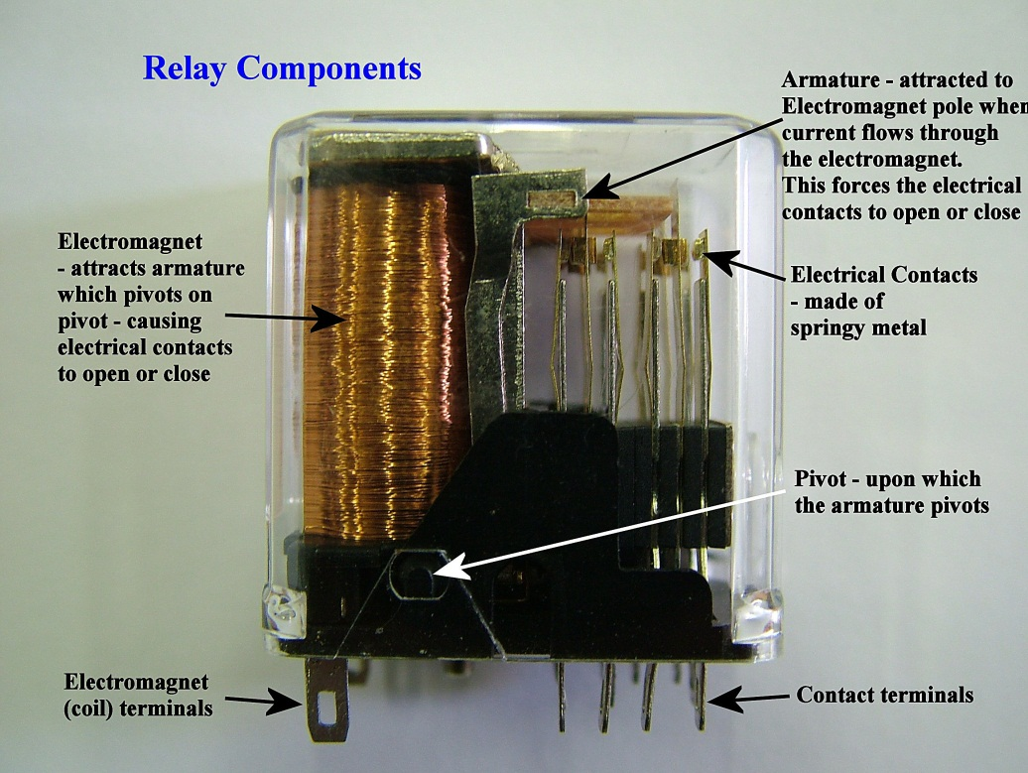The relay is used to mechanically switch on or off a circuit. A current is passed through a copper coil electromagnet producing a magnetic field which attracts the armature which rotates around the armature pivot and completes the circuit.   
  
The relay has two positions is can be connected into. The first is Normally Open – in which the normal state of the relay is open circuit (and a voltage must be applied across the electromagnet terminals in order to cause the contact terminals to “close” and complete the circuit).

The second is Normally Closed – in which the normal state of the relay is closed circuit (here a voltage must be applied to the electromagnet terminals in order to stop current flow through the contact terminals).

The relay has the weakness that its switching action relays upon mechanical movement. This means that it is prone to failure (or the need for regular adjustment). This has lead to it being replaced in circuits by the transistor which has no mechanical parts.

## Rectifiers

Rectifiers use the properties of diodes to limit circuit voltage and to rectify AC current and produce a stable DC voltage. Typically a transformer is used to reduce the voltage to 5-12 volts, then the rectifier is used to give a rectified voltage (varying DC). A capacitor and resistor are then used to produce a “smoothed” and stable DC voltage.

