Students adding OneNote to their Laptops
- Students need to select your MS TEAM (i.e. below)
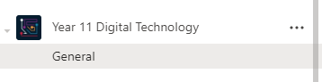
- Select Class Notebook
- Select OPEN in APP
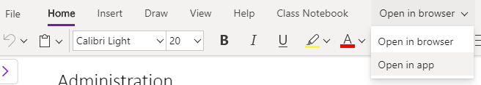
- Once OneNote opens they can pin that to their task bar, and work from there in the future
