Learning Physics Is Tough. Get Used to It
RHETT ALLAIN

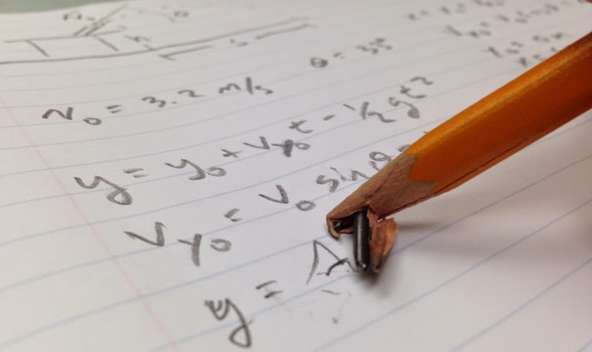

Making mistakes is just part of learning physics

IN RECENT COURSES, I have noticed two troubling practices of physics students. The first is the student response to homework problems. I hear the following kind of statements all too often:

“Oh, you are stuck on homework problem number 13? I found a solution on YouTube. That helped a lot. Just Google it, you can find all the solutions.”

The second problem is partially my fault. When I give an in-class assessment, I leave the solution out on the front desk so that students can check their answers when they are finished. Instead of studying this and figuring out their mistakes, students will usually just take a quick picture of the solutions using their phone. Of course they ask if it’s OK to take a snapshot first, and I let them. However, the problem is that they think of the solution as something to collect rather than something to learn from.

Here is the most important lesson for physics students (and really all students). The learning process is difficult. If learning was easy they would call it pie (as easy as pie—although I don’t really understand that line). If a student is doing homework or studying and there is no struggle, there is no learning. Without confusion, the student either already understood it or never tried.

This comes back to my favourite line: Confusion is the sweat of learning.

You can’t just google a physics solution and expect to learn. Imagine if Luke Skywalker had access to the Internet on Dagobah. Here’s what would have happened when his x-wing sunk beneath the water.

Yoda: So certain are you? Always with you what cannot be done. Do you nothing that I say?
Luke: Master moving stones around is one thing, but this is entirely different. But let me just Google “how to lift an x-wing with the Force.” Ah. Here it is.

Of course that’s not what happened (I would make this alternate scene into a comic if I could actually draw). Luke learned about the Force by failing. Yes, students learn physics by working on problems and by failing to solve problems. It’s the journey to the solution that’s important, not the solution itself. Using a video solution would be like using a golf cart to run 5 miles. Sure, you end up in the same place if you run or ride—but they do not produce the same results.
But why do students think this? Why do they think learning is as simple as quick search or a photo with their smart phone? There are likely many reasons for students to hold these learning beliefs. However, I popular media often doesn’t help. Remember this scene from The Avengers?

SHIELD agent Maria Hill asks Tony Stark: “When did you become an expert in thermonuclear astrophysics?” Stark’s answer: “Last night”. This shows that Tony Stark is so awesome he just figured astrophysics out last night. Clearly, students feel that you have to be a special superhero to understand astrophysics. You either get it in one night, or you’ll never get it. I would prefer to have Stark say “Well, I’ve been working in this field for 10 years and I’m just scratching the surface.” Maybe that wouldn’t fit too well in the movie.

Or here’s another good one from Days of Thunder.

Cole pulls up to the race track to test out a stock car.

Harry Hogge: What do you know about stock car racing?
Cole Trickle: Well… watched it on television, of course.
Harry Hogge: You’ve seen it on television?
Cole Trickle: ESPN. The coverage is excellent, you’d be surprised at how much you can pick up.
Harry Hogge: I’m sure I would.

See. Learning is simple. You just need to watch some videos and you’ll be all set—except when you aren’t. Nope. Learning is tough, but it’s totally worth it.

