# Year 13 Electronics - Introductory Unit

# The Basics of Electronics

## Fundamental Quantities and SI Units

There are seven fundamental quantities from which all others are derived. These are shown below

|  |  |  |  |
| --- | --- | --- | --- |
| ***Physical Quantity*** | ***Formula Symbol*** | ***SI Unit*** | ***SI Unit Symbol*** |
| Length | l | metre | m |
| Mass | m | kilogram | kg |
| Time | s | second | s |
| Temperature | T (or θ) | kelvin | K |
| Current | I | ampere | A |
| Amount of Substance | n | mole | mol |
| Luminous Intensity | I | candela | cd |

## Scientific Notation, Standard Form and Engineering Form

***Scientific notation*** is when a number is expressed in exponent form i.e. 35400 expressed as 35.4 x 103

***Standard form*** is when a number is expressed in exponent form but the lead number is a number between 0 and 10 (in the above example the number is expressed as 3.54 x 104)

***Engineering form*** is when the number is expressed in exponent form where the exponent is a multiple of a power of (x 103) (i.e. in the above example the number would be expressed as 35.4 x 103 or 0.0354 x 106 or 35400 x 100)

## Metric Prefixes

These are often used instead of engineering form. They are placed in front of a SI unit to make units of appropriate size (i.e. mm instead of m). However we need to be careful to ensure we carry out our calculations in SI units – not the non SI units provided by these metric prefixes.

|  |  |  |  |  |  |  |  |  |
| --- | --- | --- | --- | --- | --- | --- | --- | --- |
| ***Prefix Symbol*** | p | n | μ | m | k | M | G | T |
| ***Prefix Name*** | pico | nano | micro | milli | kilo | mega | giga | tera |
| ***Prefix means*** | 1 x 10-12 | 1 x 10-9 | 1 x 10-6 | 1 x 10-3 | 1 x 103 | 1 x 106 | 1 x 109 | 1 x 1012 |

## Basic Skills

### Graphing

**line graph** a graph used when both ***variables*** are able to ***change continuously***

**variable**  a ***quantity*** whose values can ***change*** depending on the ***conditions***

**independent variable** the variable whose values are ***chosen*** or ***set***

**dependent variable** the variable where there is ***no control*** over the values

**range**  includes the ***lowest*** and ***highest*** values in a ***set*** of ***data***

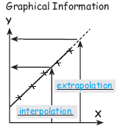

**linear scale** a scale where each ***division*** is ***worth***  the ***same amount***

**best-fit line** used to show the ***shape*** of the graph ***without*** the ***fluctuations***

**slope**  calculated by ***dividing*** the ***rise*** by the ***run***

**interpolation** the process of finding information ***between plotted points***

**extrapolation** the process of finding information ***beyond the plotted points***

**empirical equation** ***formula*** derived from ***plotted***  ***measurements***

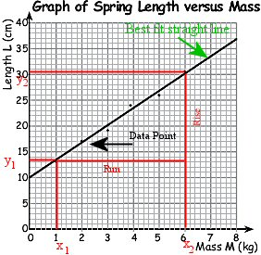

***Summary of the steps of graph plotting***

1. Rule two ***axes*** on suitable graph paper.
2. Identify the ***variable*** to go on each axis.
3. Decide on the ***range*** for each variable.
4. Mark a ***linear*** scale on each axis (must go up in either 1, 2, 5, 10, 20 or 50’s or multiples there of)
5. Label the ***quantity, formula*** symbol and ***unit*** symbol of each axis.
6. Add an appropriate ***title*** to the graph.
7. Plot the data points using ***crosses***.
8. Draw a ***best-fit*** line to show the ***shape*** of the graph.

Analysing Straight Line Graphs

***Calculating the slope of a graph and finding the empirical equation of the graph***

1. Calculate the ***rise*** (***y2 – y1***) and ***run*** (***x2 –x1***) of the graph line.

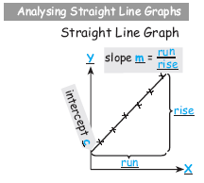

1. Calculate the value of the slope ***m***: 
2. Find the value of the intercept ***c*** on the ***vertical*** axis
3. Identify the variable symbols to replace Y and X.
4. Write the general straight line equation   
   Y = ***m***X + ***c***.
5. Substitute the replacement symbols for Y and X and the values of ***m*** and ***c*** into Y = ***m***X + ***c***.

## Nuclear%20Physics%20-%20Rutherford%20Bohr%20ModelElements and Atoms

***Elements***:- Made up of atoms of only one kind and cannot be broken down into simpler substances

***Atoms***:- The smallest piece of an element. If an atom is broken up further it doesn’t behave like that element

## Atomic Structure

* The Greeks (approx 400 BC) thought that matter must have a single smallest bit. They called this “bit” the ***atom*** (***atomos*** – smallest)

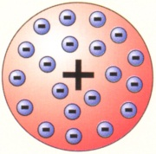

* J.J. Thompson (1903) postulated his “plum pudding” model which suggested the atom was a sphere of positively charged matter with negatively charged particles (probably the electrons he had discovered just before the turn of the century) embedded in it (a little like raisins in a Christmas Cake or plum pudding)

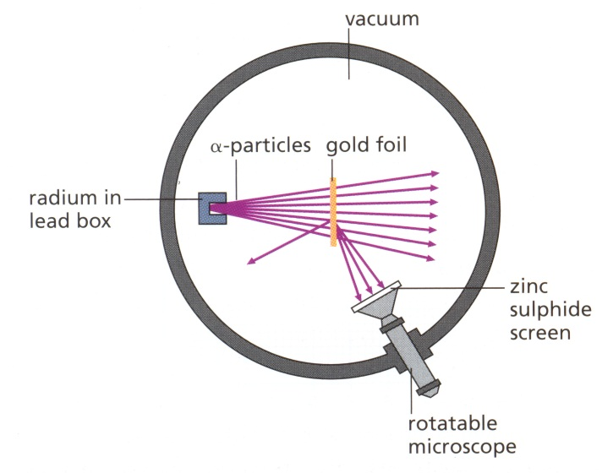

* Ernest Rutherford (1911) and his PhD student Marsden bombard an extremely thin sheet of gold with alpha (α) particles (known to be reasonably “heavy” and positively charged and later found to be a helium nucleus stripped of its electrons) in a vacuum. Marsden discovers that most α particles pass straight through the gold foil (causing scintillations (bright flashes) on the phosphorescent screen behind the gold foil), while some are scattered at relatively minor angles. Rutherford proposed that Marsden count the number of scintillations when the screen is in front of the gold foil. To everyone’s surprise Marsden was able to obtain some scintillations in this position.
* Rutherford reasoned

1. 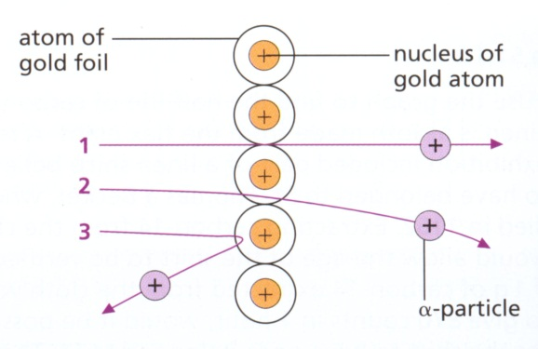that since most α particles passed straight through the gold foil – that the atom must be mostly empty space
2. that since some α particles where scattered behind the gold foil – that the atom must be charged
3. that since a few α particles where scattered by more than 90˚
   1. that the atom must be made up of a massive centre (since the heavy α particles have been bounced backwards (and not the gold foil))
   2. that the massive centre must be positively charged to provide the repulsive electrostatic force needed to repel the positive α particles.

* James Chadwick (1932) discovers the neutron and our “modern” Rutherford – Bohr model of the atom is complete. A central nucleus made up of protons and neutrons, with “orbiting” electrons placed in shells (filled 2, 8, 8, 18, 18 ….)
* 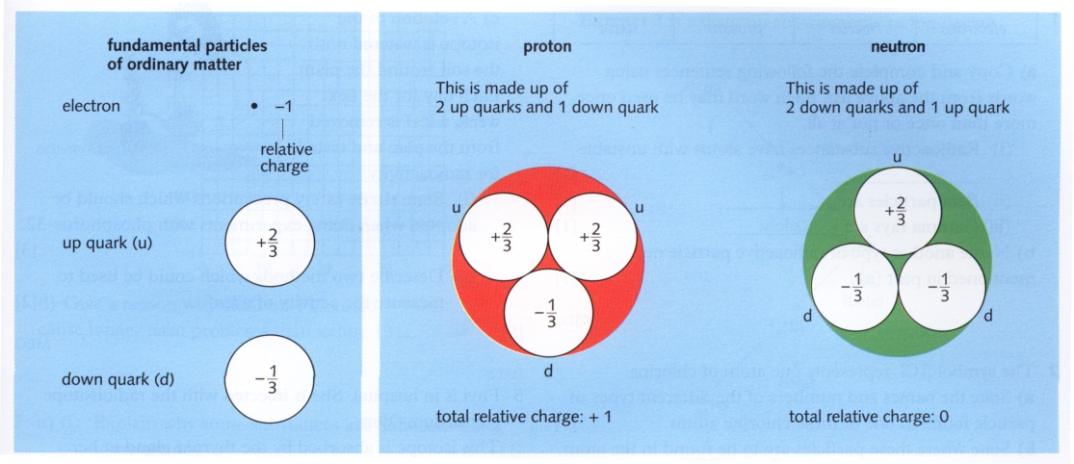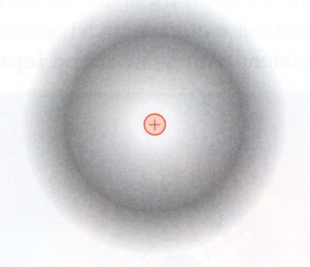Current thinking on the atom is given by Wave Mechanics – which gives the probability of an electron being in a particular location. Also Quantum Mechanics gives us that the sub atomic particles of the atom are made up of still smaller particles called Quarks.

## Composition of the Atom

* ***Atomic Number, Z***, is the number of protons in the nucleus
* ***Mass (or Nucleon) Number, A,*** is the number of ***nucleon's*** in the nucleus (a nucleon is the general name for any particles in the nucleus i.e. either a proton or a neutron)
* ***Neutron Number, N***, is the number of neutrons in the nucleus
* The Atomic Number is given by 
* Each element is represented by   
  i.e.    
  or  (has 11 protons and 11 electrons (with electrons packed in the order 2, 8, 1) and has 12 neutrons (23-11))

## ELECTRICAL PARAMETERS

## Charge

Charge is the fundamental unit in Electronics. It is because of charge that we can obtain the effects we need to produce electronic devices which achieve the results we desire.

Charge is usually thought of as ***electrons*** accumulating in one place. However there are several other alternate ways of looking at this. One such way is called ***holes***. These are an “absence of electrons.” In an atom this means the atom has overall a positive charge (has become an ion). Alternatively we can think of ***protons*** which have a positive charge.

The charge on an electron is very small (one unit of charge); so much so that we normally think in terms of a group of electrons (like thinking of a class instead of an individual pupil in a school). ***This group of electrons contains 6.3 x 1018 electrons and is called a*** “***coulomb***” (Formula symbol ***Q***, unit symbol ***C***).

In electronics we use this fundamental unit (the coulomb).

## Electric%20Field%20from%20a%20Point%20ChargeElectric Field

A charge produces a field around it which can be felt as a force acting upon another charge or object containing charges.

This is the “force” we feel when we place the back of our hands near a Van der Graaf generator and feel the hair on the back of our hand stand up.

A single point charge (a proton or an electron) has an ***electric field*** which produces an ***electric force*** on another point charge. The electric field for a point charge has a radial shape as shown in the diagram to the left.

The circular lines in this diagram are lines of ***equipotential*** (equal potential). The ***electric potential (V)*** is defined as the ***work done (W)*** in moving a ***charge, q*** from infinity to the place of interest.   
  
i.e. 

The SI unit of electric potential is the ***volt (V).***

***Example: -*** If ***1000 J of energy is required to bring a charge of +2 C from infinity to a point P, then the potential at P is given by*** 

* Electric Potential is a scalar
* At infinity the electric potential is zero
* Elsewhere the electric potential due to a positive charge is positive; while that due to a negative charge is negative
*  can also be used to find the work done in moving a charge ***q*** between two points. In this case, ***V is the potential difference (p.d.) between the points***.

## Conductors

Electrical conductors are materials that contain charges that are free to move. They allow current to easily pass through them. The best examples are gold, silver and copper.

## Insulators

Electrical insulators do not allow charge to pass through them and hence do not (easily) conduct electricity. In insulators all the electrons are bound firmly to their respective atoms, making charge flow difficult. They can however store excess charge on the insulators “surface.” This effect is seen when a ruler is rubbed on a jersey. The excess electrons rubbed onto (or off) the ruler stay on the surface of the ruler where they can influence objects in close proximity (such as a water stream or strips of paper) with their electric field.

## Current

An electric current is produced when electric charge (electrons or ions) move in a definite direction. This movement may be revealed by making a metal warmer or deflecting a near by magnetic compass.

Current is defined by looking at how many charges pass a certain point in a circuit per second. The natural unit of charge is the coulomb (as talking in terms of single electrons gives very large numbers). Hence the ***current, I***, flowing passed a point on a circuit is defined as   
   
Where ***Q*** is the number of coulombs of charge passing that point and ***t*** is the time taken.

Current is measured in the SI unit ***Ampere (A)*** (named after the famous French Scientist Amperé. However the Ampere is a large unit. Usually we measure current in the smaller unit ***milliamp (mA) (1 x 10-3 A)*** or ***microamp (μA) (1 x 10-6 A)*** – however to use the formulae in Electronics we must always remember to convert these back to the SI unit Ampere.

***Example:*** If 6 C passes in 2 seconds then the current is 

## Electron vs. Conventional Current

Before the electron was discovered Benjamin Franklin made a “convention” that “positive current” moved from the positive terminal of a battery to the negative terminal of a battery. This is called conventional current and was widely adopted by the scientific community.

At the turn of the 20th Century J.J Thomson discovered that it was actually the electron that was moving in a circuit and that it was flowing from the negative terminal to the positive terminal. This was called electron flow.

The original choice has been kept because it does not matter which direction is chosen provided we always keep to the same one.

## Voltage

Voltage is defined as the amount of electrical potential energy that a coulomb of charge possesses   
(but see the previous section on the ***Electric Field and Potential***)

i.e. 

Where ***EP*** is the electrical Potential Energy, ***W*** is the work done, and ***Q*** is the number of coulombs of charge.

***Effectively the voltage is a measure of the difference in energy between two points.***

***Example:*** ***For every 2 coulombs of charge passing through a resistor, 3 J of energy is converted to heat. What is the voltage across the resistor?***



There are two main voltages we are interested in obtaining in a circuit

### Cell%20-%20AA%20and%20DEMF – Electromotive Force, ε

This is the “energy per coulomb” supplied to the circuit by the power supply. It is measured by placing a voltmeter across the positive and negative terminals.

The voltage across a cell gradually decreases throughout its lifespan; as the chemicals which make up the cell are “exhausted” they producing an internal resistance to the production of electrical potential energy by the remaining chemicals.

### Potential Difference (p.d.)

This is the loss (or difference) in energy per coulomb as charge crosses a device in the circuit such as a resistor. This energy is transformed (or transduced) into another form of energy (usually heat or light)

Normally we consider one point in a circuit to have zero potential – and we measure all other potentials relative to this. The potential at any point is then the potential difference (p.d.) between the point and 0 V.

The point chosen as zero volts is called a ***ground, common or an earth*** and has the symbols 

## Resistance – Ohm’s Law

Resistance is defined as the ratio of voltage to current i.e.  - this is called ***Ohm’s Law***.

Resistance is measured in Ohm’s (Ω). It is a measure of the resistance to charge movement in the medium of interest. The higher the resistance the harder it is for charge carriers to move through the media.

Conductors that obey Ohm’s Law are called ***Ohmic***; those that don’t are called ***Non-Ohmic***.

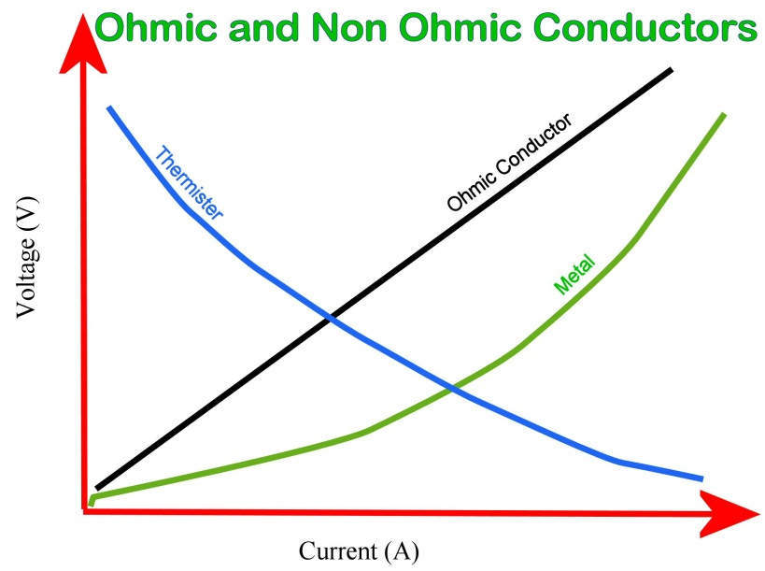Resistance is known to be temperature dependant – hence usually the resistance is measured at 25˚C.

***In Metals*** – As a metal heats up the lattice begins to vibrate more violently – hindering the progress of the electrons as they drift from one area to another – hence the resistance actually increases as the metal heats up.

***In Semiconductors*** – the lattice vibration actually releases electrons – leaving behind holes. The released electrons are then free to be used. The holes also allow drift electrons a place to move to. This hole – electron combining is called recombination and usually results in energy being released (i.e. LED’s light)

## Fixed Resistor Characteristic Curve Practical.

In this practical you will investigate the resistance of a fixed resistance using graphical techniques. You will be supplied with a single resistor of unknown resistance. You will be expected to find out its resistance.

***Student Name:***

1. Set up the following circuit – Before you connect and power up the circuit ask your teacher to check your connections

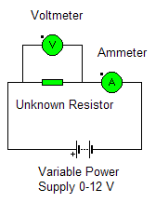

1. Set the Voltage across the resistor to the values indicated in the table as ***V***. Using the multimeters in the positions shown record the voltage across the resistor and the current flowing in the circuit using the data table.

|  |  |  |  |  |  |  |  |
| --- | --- | --- | --- | --- | --- | --- | --- |
| V(V) | 0.0 | 1.0 | 2.0 | 3.0 | 4.0 | 5.0 | 6.0 |
| I(A) |  |  |  |  |  |  |  |

|  |  |  |  |  |  |  |  |
| --- | --- | --- | --- | --- | --- | --- | --- |
| V(V) | 7.0 | 8.0 | 9.0 | 10.0 | 11.0 | 12.0 | 13.0 |
| I(A) |  |  |  |  |  |  |  |

1. Plot the voltage ***V*** (*y axis*) versus current ***I*** (*x axis*) using the graph paper on the following page. Make sure your current readings are in Ampere (***not milli or microampere***)
2. Compare Ohms law () with the equation for a straight line (). Using this information what does the slope of your graph physically represent?

1. Calculate the slope of the graph (showing full working and slope triangle construction lines on the graph)
2. What is the resistance of the unknown resistor?

***The Voltage versus Current Characteristic Curve for an Unknown Resistor***  
  


**V (V)**

**I (A)**

## Light Bulb Resistor Characteristic Curve Practical.

***Student Name:***

In this practical you will investigate the resistance of a bulb using graphical techniques. You will be supplied with a single bulb of unknown resistance.

1. Set up the following circuit – Before you connect and power up the circuit ask your teacher to check your connections  
    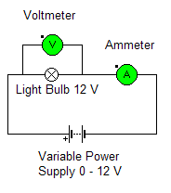
2. Set the Voltage across the resistor to the values indicated in the table as ***V***. Using the multimeters in the positions shown record the voltage across the resistor and the current flowing in the circuit using the data table.

|  |  |  |  |  |  |  |  |
| --- | --- | --- | --- | --- | --- | --- | --- |
| V(V) | 0.0 | 1.0 | 2.0 | 3.0 | 4.0 | 5.0 | 6.0 |
| I(A) |  |  |  |  |  |  |  |

|  |  |  |  |  |  |  |
| --- | --- | --- | --- | --- | --- | --- |
| V(V) | 7.0 | 8.0 | 9.0 | 10.0 | 11.0 | 12.0 |
| I(A) |  |  |  |  |  |  |

### 

1. Plot the voltage ***V*** (*y axis*) versus current ***I*** (*x axis*) using the graph paper on the following page. Make sure your current readings are in Ampere (***not milli or microampere***)
2. Compare Ohms law () with the equation for a straight line (). Using this information what does the slope of your graph physically represent?
3. Does this resistor obey Ohm’s Law? Why/Why not?
4. What is happening to the resistance of the bulb? Please explain?

***The Voltage versus Current Characteristic Curve for a Light Bulb***  
  


**V (V)**

**I (A)**

## Resistors in Series

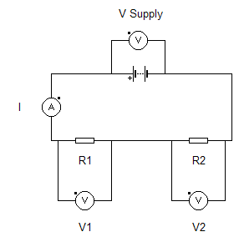

* ***Current*** is the ***same everywhere*** in the circuit

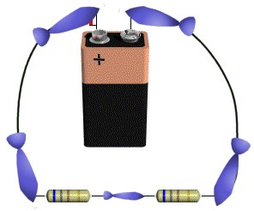

* ***Voltage*** is ***divided*** in proportion to the size of the resistors in the circuit.  
  i.e. 
* ***Resistance***: Using the relationship for voltage above and Ohm’s law ***V= IR***, the supply voltage becomes  
   since the current is the same everywhere.   
  Taking out the common factor of ***I*** we obtain 
* ***Power*** as  therefore in series circuits  or  
   ***The Power Input = Sum of the Power Outputs of each Resistor***

## Resistors in Parallel

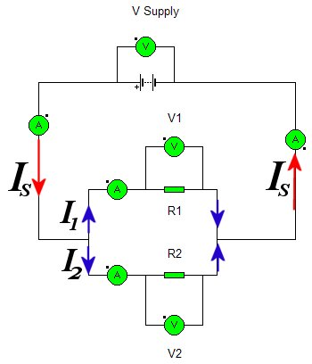

* ***Voltage*** – the voltage drop across each branch of the circuit is the same i.e. 

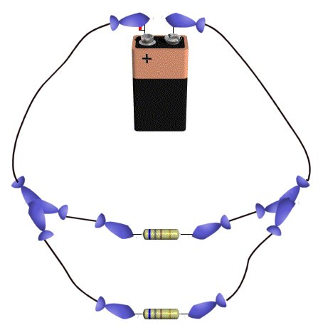

* ***Current*** – The supply current divides into two currents ***I1*** and ***I2***  
  i.e. 
* ***Resistance*** – Since the current divides as shown above and Ohm’s Law is given by   
    and since the voltage is the same everywhere we can take out the common factor of ***V*** hence 
* ***Power*** – Since   
   or ***The Power Input = Sum of the Power Outputs of each Resistor***

## Example of Resistors in parallel

***In the circuit on the left …***

1. 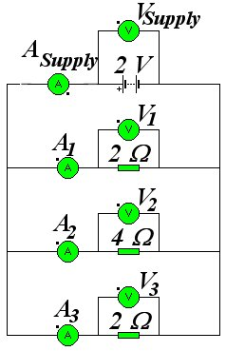***What will be the reading on voltmeter VSupply?***  
    2 V
2. ***What will be the reading on voltmeter V1?***  
    2 V – parallel resistors have the same voltage
3. ***What will be the reading on voltmeter V2?***  
    2 V – parallel resistors have the same voltage
4. ***What will be the reading on voltmeter V3?*** 2 V – parallel resistors have the same voltage
5. ***What will be the reading on ammeter A1?***  
    
6. ***What will be the reading on ammeter A2?*** 
7. ***What will be the reading on ammeter A3?*** 
8. ***What will be the reading on ammeter ASupply?*** Current in parallel circuits divide according to the rule   
    Hence ***ISupply*** = 1 + 0.5 + 1 = 2.5 A
9. ***What is the total resistance of the circuit?*** There are two possible ways to obtain the solution   
      
    ∴   
    or we could use Ohm’s Law 

## Summary

|  |  |  |
| --- | --- | --- |
|  | ***Series*** | ***Parallel*** |
| ***Current*** | Same | Shared |
| ***Voltage*** | Shared | Same |

## Compound Circuits

When we have more than just parallel or just series circuits we need to break the circuit down into smaller components to make the maths easier. We still use the same principles as we have seen above for series and parallel circuits to help us to analyse the circuit

## Example:

***Find the total equivalent resistance RT which would give the same circuit properties as the following circuit***

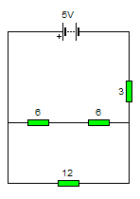

1. Here we must break the circuit down into smaller segments and slowly build up to the “complete” circuit. We start with the two 6 Ω resistors  
     
   Two Series Resistors are added   
     
     
   

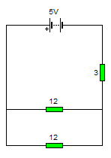



i.e. ***R6+6*** = 6 + 6 = 12 Ω   
hence the circuit now looks like the circuit on the far right

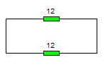

1. The next step is to work on the parallel arrangement  
     
   Parallel Resistors are combined according to:   
   hence   
      
    ∴  hence the circuit now look like this   
   which is much easier to deal with than the original.

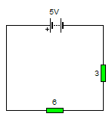

1. The next step is to combine the series resistors.  
   They are in series hence we can use   
   i.e. 

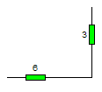

1. Hence our original circuit now looks like

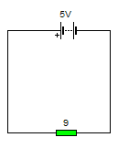

## Power rating

When current flows through a resistance, electrical energy is converted into heat. This is obvious in an electric torch where the lamp filament heats up and glows white hot. Although the result may be less evident or imperceptible, exactly the same process of energy conversion goes on when current flows through any electronic component.

The ***power output of a lamp, resistor, or other component, is defined as the rate of change of electrical energy to heat, light, or some other form of energy***. Power is measured in ***watts****,* ***W***, or **milliwatts**, **mW**, and can be calculated from:  
  
  where P is power.

What is the power output of a resistor when the voltage across it is 6 V, and the current flowing through it is 100 mA?



i.e. 0.6 Watts of heat is generated from this resistor. To prevent overheating, it must be possible for heat to be lost, or ***dissipated***, to the surroundings at the same rate.

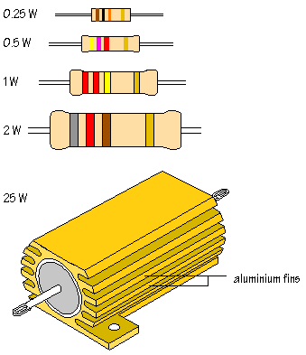A resistor's ability to lose heat depends to a large extent upon its surface area. A small resistor with a limited surface area cannot dissipate (=lose) heat quickly and is likely to overheat if large currents are passed. Larger resistors dissipate heat more effectively.

Look at the diagram that shows resistors of different sizes:

The standard size of carbon film resistor used in most circuits has a power rating of 0.5 W. This means that a resistor of this size can lose heat at a maximum rate of 0.5 W. In the example above, the calculated rate of heat loss was 0.6 W, so that a resistor with a higher power rating, 1 W or 2 W, would be needed. ***Some resistors are designed to pass very large currents and are cased in aluminium with fins, called heat sinks***, ***to increase surface area and promote heat loss.***

Input and signal processing subsystems in electronic circuits rarely involve large currents, but power rating should be considered when circuits drive output transducers, such as lamps, LEDs, and loudspeakers.

## Resistor Checkpoints

.  
***CHECKPOINT A***

1. List three ways in which resistors are used in circuits.

2. What is a transducer?

3. Give examples of input and output transducers.

.  
***CHECKPOINT B***

1. List three different manufactured types of resistor,

2. What resistor values are indicated by the following colour bands?

(A) brown, black, red  
(B) grey, red, brown  
(C) orange, white, green

3. What are the colour codes for the following resistance values?

(A) 1.8 kΩ  
(B) 270 Ω  
(C) 56 kΩ

4. What are the maximum and minimum values of a resistor with a nominal value of 220 , marked with a gold tolerance band?

.  
***CHECKPOINT C***

1. What resistor values are indicated by the following colour bands?

(A) orange, orange, black  
(B) grey, red, gold  
(C) orange, orange, black, red

2. What is the colour code for a 10 kΩ resistor  
 (A) using the three colour system?  
 (B) using the four colour system

.  
***CHECKPOINT D***

1. Which E12 value is closest to 5 030 Ω?

.  
***CHECKPOINT E***

1. In the circuit for lighting an LED, the power supply is   
  
changed to 6 V:

What should be the new value for R1?

.

  
***CHECKPOINT F***

1. In the circuit to the right:

what is

(A) the total resistance in the  
  
 circuit?  
  
(B) the current flowing at point  
  
 A?

2. In the circuit to the left:

what is

(A) the total resistance in the circuit?  
(B) the current flowing at points B, C, and D?

.  
CHECKPOINT G

1. Which power rating of resistor is required for a 680 Ω current limiting resistor in series with an LED if the current flowing is 10 mA?

***ANSWERS A***

1. To limit current, with a transducer as part of a sensor subsystem, with a capacitor to introduce a time delay.

2. A component which changes one form of energy into another, where one of the forms of energy is electrical.

3. Input: LDR, microphone, switch, thermistor (temperature sensitive) Output: LED, lamp, loudspeaker, buzzer.

.  
***ANSWERS B***

1. Carbon film, metal film, wire-wound.

2. Resistor values:

(A) 1000 Ω, or 1 kΩ  
(B) 820 Ω  
(C) 3 900 000 Ω, or 3.9 MΩ.

3. Colour codes:

(A) brown, grey, red  
(B) red, violet, brown  
(C) green, blue, orange

4. Gold = ±5% maximum: 220+11=231 Ω minimum: 220-11=209 Ω

***ANSWERS C***

1. Resistor values:

(A) 33 Ω  
(B) 8.2 Ω  
(C) 33 000 Ω, or 33 kΩ

2. Colour codes:

(A) brown, black, orange  
(B) brown, black, black, red

***ANSWERS D***

1. E12 values of 4.7 kΩ and 56 kΩ are available: 4.7 kΩ is closer. On the E24 scale, 5.1 kΩ is closest.

***ANSWERS E***

1. The voltage across R1 is now 6-4=2 V

Image33

The closest E12 value is 390 Ω, colour code orange, white, brown.

***ANSWERS F***

1. Resistors in series:

(A) 3 kΩ  
(B) 2 mA

2. Resistors in parallel:

(A) 0.67 kΩ  
(B) B=9 mA, C=6 mA, D=3 mA

The resistors connected in parallel have different values and it follows that the currents flowing through them will be different.

***ANSWERS G***

1. 10 mA=0.01 A. The voltage across the 680 Ω is:

Image34

The power is:

Image35

Any resistor of a higher rating will do either 0.25 W or 0.5 W.