## Potential Dividers Subsystems

***Electronic circuits are built up of subsystems and are thought of in terms of INPUT, PROCESS, OUTPUT***.

Between the subsystems signals are transferred. These signals are almost always transferred as changing *voltages*. This makes it inevitable that electronic circuits include voltage dividers as an integral part of their structure.

Voltage dividers aren't just a little bit important, they are fundamental to an understanding of electronic circuits. Once you have started to look for them, you will find them everywhere.

**What is a potential (voltage) divider?**

You are going to find out but don't be in too much of a hurry. Work through this section and allow the explanation to develop.

## Potential%20DividerPotential Dividers

* Are a useful way to split up and obtain a desired voltage from a fixed voltage source
* the idea is to have two resistors in series of an appropriate size so that the voltage drop across one of them is the desired voltage
* by placing a load in parallel with that resistor the load is then at the same voltage as the resistor (almost!)
* 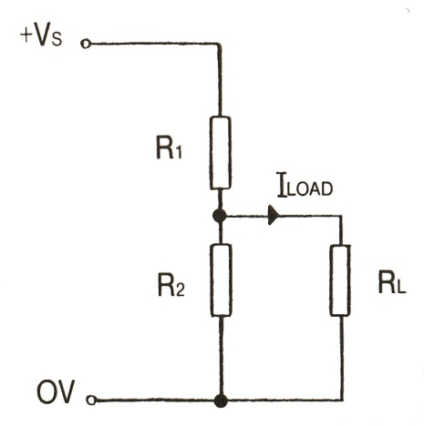The current at any point on the circuit is given by Ohm’s Law 
* 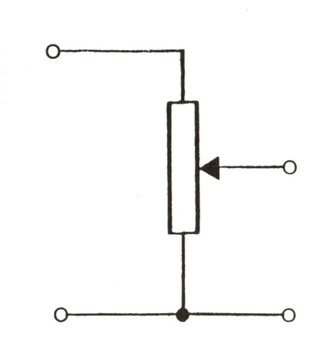it should be immediately obvious that the voltage  or 

The position of the slider determines the ratio of the resistances on either side of it and thus the voltage ratio also

* Often a potentiometer is used to provide a variable potential divider. This gives control over the voltage experienced by the load.
* An example is the volume switch of a stereo system.

**Light sensors**

The diagram below shows a **light dependent resistor**, or **LDR**, together with its circuit symbol:



The light-sensitive part of the LDR is a wavy track of cadmium sulphide. Light energy triggers the release of extra charge carriers in this material, so that its resistance falls as the level of illumination increases.

A **light sensor** uses an LDR as part of a voltage divider.

The essential circuit of a voltage divider, also called a **potential divider**, is:

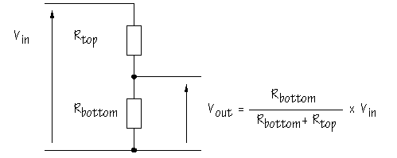

As you can see, two resistors are connected in series with *V*in , which is often the power supply voltage, connected above *R*top . The output voltage *V*out is the voltage across *R*bottom and is given by:

|  |
| --- |
| Image41 |

It may help you to remember that *R*bottom appears on the top line of the formula *because* *V*out is measured across *R*bottom .

|  |  |
| --- | --- |
| g_blue_aKEY FORMULA: | This is an extremely useful formula which you should learn thoroughly |

What happens if one of the resistors in the voltage divider is replaced by an LDR? In the circuit below, *R*top is a 10 kΩ resistor, and an LDR is used as *R*bottom :

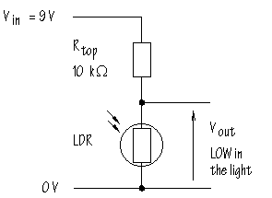

Suppose the LDR has a resistance of 500 Ω, 0.5 kΩ, in bright light and 200 kΩ in the shade (these values are reasonable).

When the LDR is in the light, *V*out will be:

|  |
| --- |
| Image41 |

Image43

In the shade, *V*out will be:

Image44

In other words, this circuit gives a LOW voltage when the LDR is in the light and a HIGH voltage when the LDR is in the shade. The voltage divider circuit gives an output *voltage* which changes with illumination.

A sensor subsystem which functions like this could be thought of as a '**dark sensor**' and could be used to control lighting circuits which are switched on automatically in the evening.

Perhaps this does not seem terribly exciting, but almost every sensor circuit you can think of uses a voltage divider. There's just no other way to make sensor subsystems work.

Here is the voltage divider built with the LDR in place of *R*top :

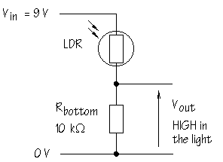

What effect does this have on *V*out ?

The action of the circuit is reversed. That is, *V*out becomes HIGH when the LDR is in the light, and LOW when the LDR is in the shade. Substitute the appropriate values in the voltage divider formula to convince yourself that this is true.

**Temperature sensors**

A temperature-sensitive resistor is called a **thermistor**. There are several different types:

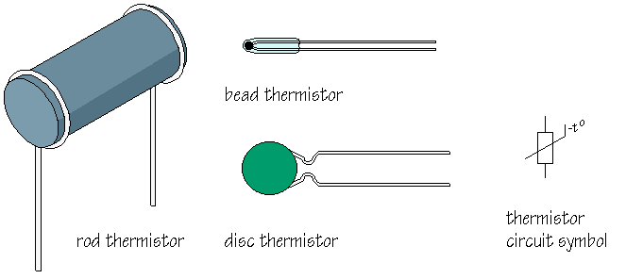

The resistance of most common types of thermistor *decreases* as the temperature rises. They are called **negative temperature coefficient**, or **ntc**, thermistors. Note the -t° next to the circuit symbol. A typical ntc thermistor is made using semiconductor metal oxide materials. (Semiconductors have resistance properties midway between those of conductors and insulators.) As the temperature rises, more charge carriers become available and the resistance falls.

Although less often used, it is possible to manufacture **positive temperature coefficient**, or **ptc**, thermistors. These are made of different materials and show an increase in resistance with temperature.

How could you make a sensor circuit for use in a fire alarm? You want a circuit which will deliver a HIGH voltage when hot conditions are detected. You need a voltage divider with the ntc thermistor in the *R*top position:

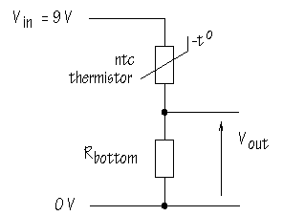

How could you make a sensor circuit to detect temperatures less than 4°C to warn motorists that there may be ice on the road? You want a circuit that will give a HIGH voltage in cold conditions. You need a voltage divider with the thermistor in place of *R*bottom :

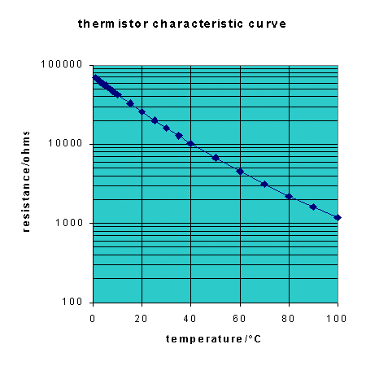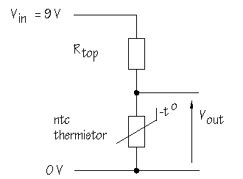

This last application raises an important question: How do you know what value of *V*out you are going to get at 4°C?

To answer this question, you need to estimate the resistance of the thermistor at 4°C.

Lots of different types of thermistor are manufactured and each has its own characteristic pattern of resistance change with temperature. The diagram below shows the **thermistor** **characteristic curve** for one particular thermistor:

On the y-axis, resistance is plotted on a logarithmic scale. This is a way of compressing the graph so that it is easier to see how the resistance changes. Between 100 Ω and 1000 Ω, each horizontal division corresponds to 100 Ω. On the other hand, between 1000 Ω and 10000 Ω, each division corresponds to 1000 Ω. Above 10000 Ω, each division represents 10000 Ω.

As you can see, this thermistor has a resistance which varies from around 70 kΩ at 0°C to about 1 kΩ at 100°C. Supplier’s catalogues usually give the resistance at 25°C, which was 20 kΩ in this case. Usually, catalogues also specify a 'Beta' or 'B-value'. When these two numbers are specified, it is possible to calculate an approximate value for the resistance of the thermistor at any particular temperature from the equation:

|  |
| --- |
| Image46 |

Where:

*RT* is the resistance at temperature *T* in Kelvin (= °C +273)  
*RT*0is the resistance at a reference temperature *T*0 in Kelvin. When the reference temperature is 25°C, *T*0 = 25+273.  
*e* is the natural logarithm base, raised to the power Image48in this equation.

*B* is the B-value specified for this thermistor.

You don't need to think about applying this equation at the moment, but it is useful to know that the information provided in catalogues is sufficient to allow you to predict thermistor performance.

Using a spreadsheet such as [*Excel*](http://www.users.dircon.co.uk/~doctron/programs/thermistor.xls), it is possible to generate characteristic curves for any thermistor by calculating resistance values for a range of temperatures.With *RT*0 = 20 kΩ and *B* =4200, resistance changes from 0 to 10°C are as follows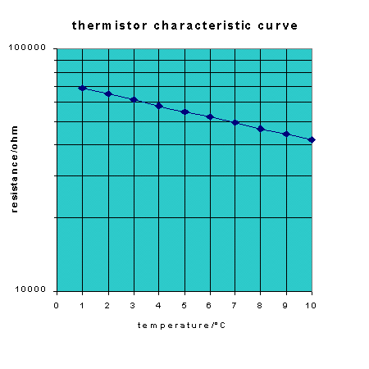  
  
From the graph, the resistance at 4°C can be estimated as just a little less than 60 kΩ. By calculation using the equation, the exact value is 58.2 kΩ.

|  |  |
| --- | --- |
| g_blue_aKEY POINT: | The biggest change in *V*out from a voltage divider is obtained when *R*top and *R*bottom are EQUAL in value. |

What this means is that selecting a value for *R*top close to 58.2 kΩ will make the voltage divider for the ice alert *most sensitive* at 4°C. The nearest E12/E24 value is 56 kΩ. This matters because large changes in *V*out make it easier to design the other subsystems in the ice alert, so that temperatures below 4°C will be reliably detected.

Sensor devices vary considerably in resistance and you can apply this rule to make sure that the voltage dividers you build will always be as sensitive as possible at the critical point. ***To make them as sensitive as possible we make sure the two resistors of the potential divider are approximately equal at the point where we want the circuit to have the most sensitivity.***

Thermistors turn up in more places than you might imagine. They are extensively used in cars, for example in:

* electronic fuel injection, in which air-inlet, air/fuel mixture and cooling water temperatures are monitored to help determine the fuel concentration for optimum injection.
* air conditioning and seat temperature controls.
* warning indicators such as oil and fluid temperatures, oil level and turbo-charger switch off.
* fan motor control, based on cooling water temperature
* frost sensors, for outside temperature measurement
* acoustic systems

Thermistors are used to measure surface and deepwater sea temperatures in helping to monitor *El Niño* ocean currents. Less obviously, thermistors are used to measure air flow, for instance in monitoring breathing in premature babies.

**Wheatstone bridge**

Sir Charles Wheatstone was a talented and versatile scientist. He invented the concertina, experimented with stereoscopic photography and invented the stereoscope and played an important part in the early development of telegraph communications. He didn't claim to have invented the circuit named after him, but was among the first to exploit the circuit effectively in making resistance measurements.

So, what is a Wheatstone bridge? This is the circuit:

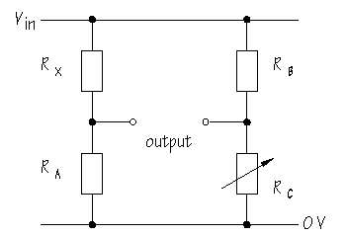



***Sir Charles Wheatstone***

It is obvious that the circuit consists of two voltage dividers. Suppose *R*X is an unknown resistor value. *R*C is adjusted until *V*out from the second voltage divider is equal to *V*out from the voltage divider containing *R*X . When the *V*out values are equal, the bridge is said to be balanced. The balance point can be detected by connecting either a voltmeter or an ammeter across the output terminals. Both sorts of meter give a zero reading when balance is achieved.

In a balanced circuit, the ratio *R*X / *R*A is equal to the ratio *R*B / *R*C . Rearranging:

|  |
| --- |
| Image49 |

In other words, if the values of *R*A , *R*B and *R*C are known, it is easy to calculate *R*X . In Wheatstone bridge instruments, *R*A and *R*B were fixed and *R*C was adjusted on a sliding scale in such a way that the value of *R*X could be read off directly.

Today, Wheatstone bridge circuits are not usually used to measure resistance values, but they *are* used in designing sensor circuits.

A **variometer** is an instrument used in gliders to detect changes in air pressure due to sudden changes in altitude. The variometer alerts the glider pilot to updrafts or thermals. By circling within a thermal the pilot can gain height and keep flying for longer.

One type of variometer uses thermistors to monitor pressure changes:

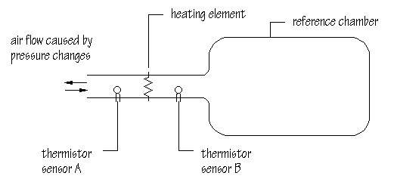

Altitude changes cause pressure changes which produce air flow. A heating element in the flow passage heats air which arrives at different temperatures at a thermistor sensor upstream and downstream of the heating element depending on the rate of air flow.

The thermistor sensors are part of a Wheatstone bridge:

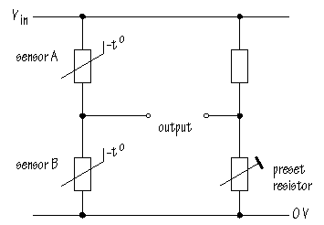

When the instrument is first set up, the preset resistor is adjusted for zero output. The advantage of the Wheatstone bridge is that only temperature *differences* between the two sensors will put the bridge out of balance. Cold or warm weather conditions affect both sensors equally. Air flow into or out of the reference chamber has the opposite effect on the two sensors: one will be heated by the airstream, while the other is cooled. As a result, the output changes by more than it would if there was just a single sensor device.

By the way, Wheatstone bridge circuits are supposed to be difficult to understand. The circuit is usually drawn as a diamond:

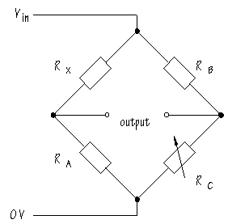

It's less obvious that you should be thinking about two voltage dividers, but once you know, the action of the circuit is easy to follow.

**Sound sensors**

Another name for a sound sensor is a **microphone**. The diagram shows a **cermet microphone**:

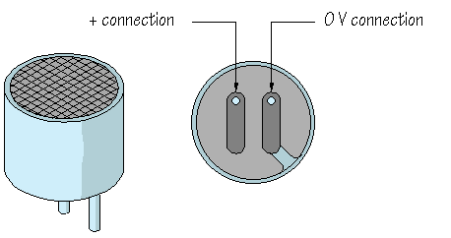

'Cermet' stands for 'ceramic' and 'metal'. A mixture of these materials is used in making the sound-sensitive part of the microphone. To make them work properly, cermet microphones need a voltage, usually around 1.5 V across them. A suitable circuit for use with a 9 V supply is:

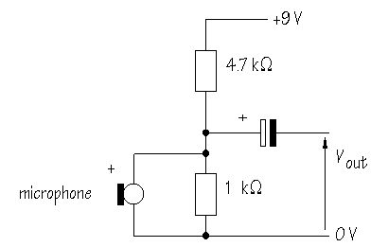

The 4.7 kΩ and the 1 kΩ resistors make a voltage divider which provides 1.6 V across the microphone. Sound waves generate small changes in voltage, usually in the range 10-20 mV. To isolate these small signals from the steady 1.6 V, a **capacitor** is used. Capacitors are described later.

**Signals from switches**

When a switch is used to provide an input to a circuit, pressing the switch usually generates a voltage signal. It is the voltage signal that triggers the circuit into action. What do you need to get the switch to generate a voltage signal? . . . You need a voltage divider. The circuit can be built in either of two ways:

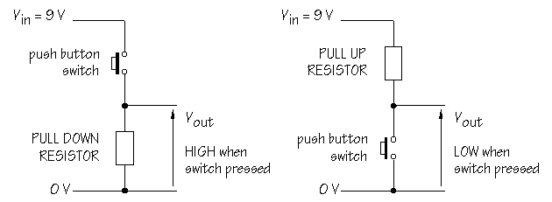

The ***pull down resistor*** in the first circuit forces *V*out to become LOW except when the push button switch is operated. This circuit delivers a HIGH voltage when the switch is pressed. A resistor value of 10 kΩ is often used.

In the second circuit, the ***pull up resistor*** forces *V*out to become HIGH except when the switch is operated. Pressing the switch connects *V*out directly to 0 V. In other words, this circuit delivers a LOW voltage when the switch is pressed.

In circuits which process logic signals, a LOW voltage is called 'logic 0' or just '0', while a HIGH voltage is called 'logic1' or '1'. These voltage divider circuits are perfect for providing input signals for logic systems.

What kinds of switches could you use. One variety of push button switch is called a **miniature tactile switch**. These are small switches which work well with prototype board:

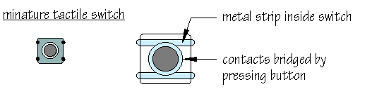

As you can see, the switch has four pins which are linked in pairs by internal metal strips. Pressing the button bridges the contacts and closes the switch. The extra pins are useful in designing printed circuit boards for keyboard input and also stop the switch from being moved about or bent once soldered into position.

There are lots of other switches which you might want to use in a voltage divider configuration. These include magnetically-operated ***reed switches***, ***tilt switches*** and ***pressure pads***, all with burglar alarm applications.

## Potential Divider Checkpoints

***CHECKPOINT A***

1. Write down the formula for calculating Vout from a voltage divider.

2. What is the alternative name for this kind of circuit?

3. Does the resistance of the LDR go down or up in bright light? Explain your answer.

4. Calculate Vout for the circuit shown below, assuming the LDR has a resistance of 2 kΩ.



5. In this circuit, does Vout increase or decrease in bright light?

6. How could you reverse the action of the circuit?

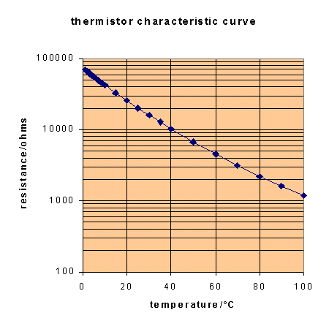.***CHECKPOINT B***

1. Distinguish between **ntc** and **ptc** thermistors. What happens to the resistance of each type as temperature increases?

2. A greenhouse fan is to start automatically if the temperature exceeds 40°C. Estimate the thermistor resistance at 40°C from the characteristic curve to the right:

3. Draw a voltage divider circuit to give an increase in Vout as the temperature rises. What should be the value of the fixed resistor for maximum sensitivity at 40°C

***CHECKPOINT C***

1. Calculate the value of RX in the Wheatstone bridge circuit shown below:



2. What are the advantages of sensor subsystems using Wheatstone bridge circuits?

***CHECKPOINT D***

1. A reed switch is closed when a magnet is placed nearby. In a burglar alarm system, the magnet is fixed to the moving part of a door or window, while the reed switch is fixed to the frame. Vout is to be LOW when the door or window is closed and is to become HIGH when the door or window is opened. Which of the voltage divider circuits shown below will give this result?



2. Suggest a value for Rtop and Rbottom in these circuits.

3. How could several reed switches be included in the same voltage divider circuit, giving a HIGH voltage when any one of the reed switches is opened?

***ANSWERS A***

1. voltage divider formula:

|  |
| --- |
| Image41 |

2. alternative name: **potential divider**

3. LDR resistance decreases in the light because light energy increases the number of charge carriers available to transfer current.

4. calculating Vout :

Image45

5. Vout increases in the light.

6. The action of the circuit is reversed by placing the LDR at the bottom of the voltage divider.

.***ANSWERS B***

1. In **ntc** or **negative temperature coefficient** thermistors, resistance decreases as temperature increases. In **ptc** or **positive temperature coefficient** thermistors, resistance increases as temperature increases. ntc types are more commonly used.

2. At 40°C, thermistor resistance is close to 10000 Ω, or 10 kΩ

3. The circuit required is:



Selecting the fixed resistor as 10 kΩ gives maximum sensitivity at 40°C because 10 kΩ is equal to the thermistor resistance at this temperature.

***ANSWERS C***

1. Substituting in formula:

|  |
| --- |
| Image49 |

Image50

2. When the bridge is in balance, only differences in temperature from the set point are detected. With two thermistors in the temperature-sensing voltage divider, the bridge automatically compensates for changes in external conditions. The Wheatstone bridge circuit provides similar advantages using other types of sensor.

***ANSWERS D***

1. Circuit A gives Vout HIGH when the door or window is opened.

2. 10 kΩ is a suitable value for any switch/resistor voltage divider.

3. To include several reed switches in the same voltage divider, they should be connected in series as shown to the right:

If any reed switch opens, Vout becomes HIGH. This works because the reed switch sensors are normally closed. Normally open switches such as pressure pads would be connected in parallel.