Assessment Schedule – 2016

Economics: Demonstrate understanding of consumer choices, using scarcity and / or demand (90983)
Assessment Criteria
Achievement | Achievement with Merit | Achievement with Excellence
Demonstrate understanding involves:  - defining, identifying, describing, or providing an explanation of consumer choices related to scarcity  - identifying, describing, or providing an explanation of choices a consumer makes in response to a change in price or non-price factors  - identifying, describing, or providing an explanation of flow-on effects for the consumer  - clearly illustrating changes using the demand model. | Demonstrate in-depth understanding involves:  - providing a detailed explanation of consumer choices related to scarcity  - providing a detailed explanation, using demand, of choices a consumer makes in response to a change in price or non-price factors  - providing a detailed explanation of the flow-on effects for the consumer. | Demonstrate comprehensive understanding involves:  - providing an integrated explanation of consumer choices related to scarcity  - linking detailed explanations of flow-on effects for the consumer with detailed explanations of choices the consumer makes in response to a change in price or non-price factors affecting demand  - integrating changes in demand into detailed explanations.

Evidence
Q  ONE | Sample answers / Evidence |  |  |  | Achievement |  | Achievement  with Merit |  |  | Achievement  with Excellence
(a)  and  (b) | 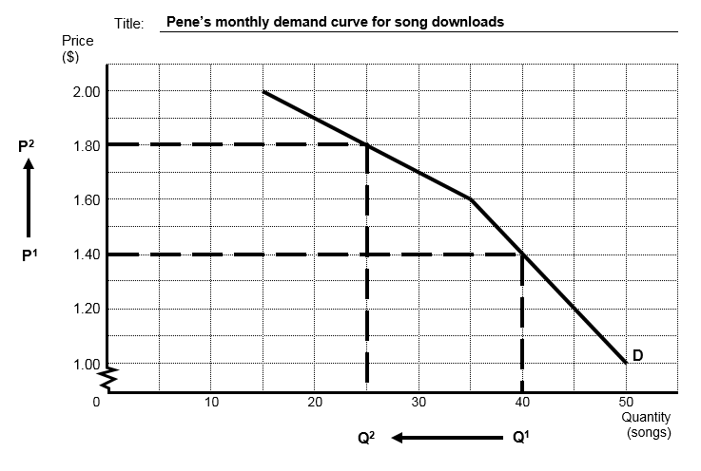 |  |  |  | Demonstrates understanding by:  - drawing the graph with FIVE correct requirements (from: title, price ($), quantity, points correct, D label, scales correct)  - identifying accurate movement up the demand curve  - describing the law of demand  - explaining a decrease in the quantity of songs  - explaining flow-on effect(s). |  | Detailed explanation, which includes fully explaining:  - the law of demand, with some reference to the information in the table or the graph  - the decrease in the number of songs downloaded by Pene  - flow-on effect(s) for Pene.  Uses detailed explanations, mostly in context. |  |  | Comprehensive explanation, which includes fully explaining:  - the law of demand in the context of the number of songs downloaded by Pene (with reference to the graph and / or the table)  - TWO flow-on effects for Pene.  Uses integrated explanations in context, and uses correct data and economic terminology.
(c) | The law of demand states that an increase the price leads to a decrease in the quantity demanded – assuming ceteris paribus (factors other than price remain unchanged).  In this case, as the price of a song download increases from $1.40 (P₁) to $1.80 (P₂) per song, Pene will decrease her quantity demanded for songs from 40 (Q₁) to 25 songs (Q₂) per month.  This is because, assuming her income remains unchanged – ceteris paribus, she can now no longer afford to download as many songs, i.e. songs have become less affordable (income effect).  Pene might also demand fewer songs because they are now relatively more expensive than a substitute good such as games, assuming the price of games remains unchanged – ceteris paribus, (substitution effect).  Possible flow-on effects (not limited to)  The price increase might lead Pene to:  - have more time for studying because she is spending less time listening to music, meaning her grades may improve  - have more time for playing games because she is spending less time listening to music, meaning her gaming skills may improve  - take on extra shifts at the supermarket. This will increase her income and make the songs more affordable again
N1 |  | N2 | A3 | A4 |  | M5 |  | M6 | E7 |  | E8
Very little Achievement evidence. |  | Some Achievement evidence, partial explanations. | Most Achievement evidence.  At least one explanation. | Nearly all Achievement evidence. |  | Some Merit evidence. |  | Most Merit evidence. | Excellence evidence.  One part may be weaker. |  | All points covered.
N = No response; no relevant evidence.

Q  TWO | Sample answers / Evidence |  |  |  | Achievement |  |  | Achievement  with Merit |  | Achievement  with Excellence
(a)  (b) | 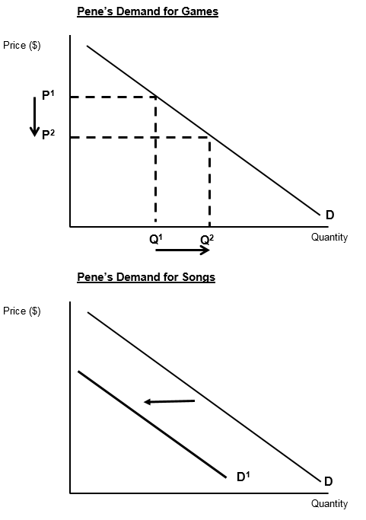  Substitutes  Games and songs are substitute goods for Pene in that they can both be used for the same purpose, in this case for Pene’s relaxation activities  Games  A decrease in the price of games leads to an increase in the quantity demanded as games are now more affordable/relatively cheaper than songs.  Songs  A decrease in the price of games leads to a decrease in the demand for songs. Pene moves her consumption of downloads from songs to games as now songs are relatively more expensive. The demand curve shifts to the left from D to D¹.  Possible flow-on effects (not limited to)  Pene may be spending more on in–app purchases as she is playing more games  Pene may have more time for studying because she is spending less time listening to music, meaning her grades may improve  Pene may have less time for studying because she is spending more time playing games, meaning her grades may get worse  Pene may need to increase the storage in her phone as game downloads are larger than song downloads and she is now downloading more games.  NB: some students may think they are complements as they can listen to music while playing games. Allow this and mark accordingly. |  |  |  | Demonstrates understanding by:  - correctly drawing both graphs  - identifies as substitutes  - identifies increased quantity of games  - shows increased quantity demanded on games graph  - identifies decreased demand for songs  - shows decreased demand on songs graph  - explaining flow-on effect(s). |  |  | Detailed explanation, which includes fully explaining:  - explains substitutes in terms of being used instead of another  - fully explains increased quantity of games demanded with some reference to graph  - fully explains decreased demand for songs with some reference to graph  - fully explains flow-on effect(s) for Pene.  Uses detailed explanations, mostly uses correct data, and in context |  | Comprehensive explanation, which includes fully explaining:  - fully explains substitutes in terms of being used instead of another in the context of Pene, making reference to the graph changes  - fully explains TWO flow on effects for Pene  Uses integrated explanations in context, and uses correct data and economic terminology.
N1 |  | N2 | A3 | A4 |  | M5 | M6 |  | E7 |  | E8
Very little Achievement evidence. |  | Some Achievement evidence, partial explanations. | Most Achievement evidence.  At least one explanation. | Nearly all Achievement evidence. |  | Some Merit evidence. | Most Merit evidence. |  | Excellence evidence.  One part may be weaker. |  | All points covered.
N = No response; no relevant evidence.

Q  THREE | Sample answers / Evidence |  |  |  | Achievement |  | Achievement  with Merit |  |  | Achievement  with Excellence
(a)  (b) | Time is a limited resource / means for Pene as there are only 24 hours in a day. This is not enough time for her to be able to do all the things she would like such as study, work at her job, listen to music, play her games, and babysit her baby brother.  Because her time is limited Pene must make a decision or choice about how best to allocate her limited time.  When choosing one alternative over another she gives up the option of using her time for the next best alternative. This is known as the opportunity cost over  For example, choosing to work at her job and earn more money means she cannot also babysit during that time. She has given up the opportunity of using that time to babysit so that is the opportunity cost.  Values are those ideas / beliefs that people consider important in their lives, and that influence their decisions.  If Pene values her education she will likely choose to study/do her homework as this will lead to her understanding her school work better.  If Pene values her family/whanau she will likely choose to babysit her baby brother. This gives her time playing with her brother and lets her parents have a break.  Pene does not have enough time to do both of these so she is conflicted about whether to study or babysit her brother.  In order to resolve this conflict, Pene could (not limited to):  - cut down her hours at the supermarket and use some of this time to play with her baby brother and some of it to do her homework. This satisfies her value of family/whanau as she is at least spending some quality time playing with her baby brother and it satisfies her value of education as she is learning more which will improve her grades  - offer to babysit her brother when he is asleep. This satisfies her value of family/whanau as it means she is contributing to her family by giving her parents a chance to have a break and she can use the time when he is asleep to do her homework which will improve her grades  or any reasonable compromise |  |  |  | Demonstrates understanding by:  - describing limited means  - identifying choice  - explaining opportunity cost  - defining the term ‘values’  - describing Pene’s decision based on each value  - explaining a conflict or a compromise. |  | Detailed explanation, which includes:  - explaining why time is a limited resource/means  - explaining choice and opportunity cost  - fully explaining Pene’s choices based on each value  - fully explaining the conflict that arises  - explains a compromise  Uses detailed explanations, mostly in context. |  |  | Comprehensive explanation, which includes fully explaining:  - the concepts of limited means, choice, and opportunity cost in the context of Pene’s options and time  - Pene’s choices for each value and the conflict she has  - the compromise and how it satisfies each value.  Uses integrated explanations in context, and uses correct economic terminology.
N1 |  | N2 | A3 | A4 |  | M5 |  | M6 | E7 |  | E8
Very little Achievement evidence. |  | Some Achievement evidence, partial explanations. | Most Achievement evidence.  At least one explanation. | Nearly all Achievement evidence. |  | Some Merit evidence. |  | Most Merit evidence. | Excellence evidence.  One part may be weaker. |  | All points covered.
N = No response; no relevant evidence.

Cut Scores
Not Achieved | Achievement | Achievement with Merit | Achievement with Excellence
0 – 6 | 7 – 12 | 13 – 18 | 19 – 24

