Assessment Schedule – 2017

Economics: Demonstrate understanding of consumer choices, using scarcity and / or demand (90983)
Assessment Criteria

Achievement | Achievement with Merit | Achievement with Excellence
Demonstrate understanding involves:  - defining, identifying, describing, or providing an explanation of consumer choices related to scarcity  - identifying, describing, or providing an explanation of choices a consumer makes in response to a change in price or non-price factors  - identifying, describing, or providing an explanation of flow-on effects for the consumer  - clearly illustrating changes using the demand model. | Demonstrate in-depth understanding involves:  - providing a detailed explanation of consumer choices related to scarcity  - providing a detailed explanation, using demand, of choices a consumer makes in response to a change in price or non-price factors  - providing a detailed explanation of the flow-on effects for the consumer. | Demonstrate comprehensive understanding involves:  - providing an integrated explanation of consumer choices related to scarcity  - linking detailed explanations of flow-on effects for the consumer with detailed explanations of choices the consumer makes in response to a change in a price or non-price factors affecting demand  - integrating changes in demand into detailed explanations.

Grade Score Descriptors
N | N1 | N2 | A3 | A4 | M5 | M6 | E7 | E8
No response;  no relevant evidence. | Very little Achievement evidence. | Some Achievement evidence, partial explanations. | Most Achievement evidence, at least one explanation. | Nearly all Achievement evidence. | Some Merit evidence. | Most Merit evidence. | Excellence evidence. One part may be weaker. | All points covered.
NB: Each question should be read as a whole before awarding a grade.

Question  One | Sample answers / Evidence
(a) | Lucy’s time is limited because there are only 24 hours in a day, which is not enough for her to do everything that she wants, eg studying at university, working in the restaurant, playing and training for netball and joining the environment group.  Because Lucy’s time is scarce, she cannot both play netball and clean up waterways with the environment group on Saturday morning, she will have to make a choice about which activity gives her the most satisfaction.  Opportunity cost is the cost of the next best alternative forgone. If she was to choose playing netball she has given up the opportunity of joining the environment group. Joining the environment group is the opportunity cost.
(b) | Values are those ideas / beliefs that people consider important in their lives, and that influence their decisions.  If Lucy values the environment she would choose to join the environment group as she will feel she is contributing to cleaning up the planet by helping to clean the city’s waterways. If she values being active and healthy she would choose to play and train for netball as this exercise will help make her fitter and healthier.  Because she cannot do both, they are both require a Saturday morning commitment, then she is conflicted.
(c) | Lucy could forgo jogging one day a week and use this time to clean up the waterways on her own. This allows her to satisfy her value of being active as she is still doing physical work cleaning the waterways, and satisfies her value of the environment as she is contributing to cleaning the waterways.  Lucy could donate some of her money from her part-time job to an environmental cause like cleaning up waterways. This allows her to continue to play netball which keeps her fit and healthy and satisfies her value of the environment as she knows her donation will help to clean up the environment.  Or any valid compromise that satisfies both values in part.
Achievement |  | Achievement with Merit | Achievement with Excellence
Demonstrates understanding by:  - describing scarcity  - identifying a choice for Lucy  - explaining opportunity cost  - defining values  - identifying a conflict  - explaining a compromise. |  | Detailed explanation, which includes:  - explaining why time is a scarce resource  - explaining choice and opportunity cost  - fully explaining Lucy’s conflict  - fully explaining compromise(s) Lucy might make. | Comprehensive explanation, which includes:  - fully explaining the concepts of scarcity, choice, and opportunity cost in the context of Lucy’s options related to Saturday morning  - fully explaining Lucy’s conflict and TWO compromises to resolve this.
 |  | Candidate uses detailed explanations, mostly in context. | Candidate uses integrated explanations in context, and uses correct economic terminology.

Question Two | Sample answers / Evidence
(a)  (b) | 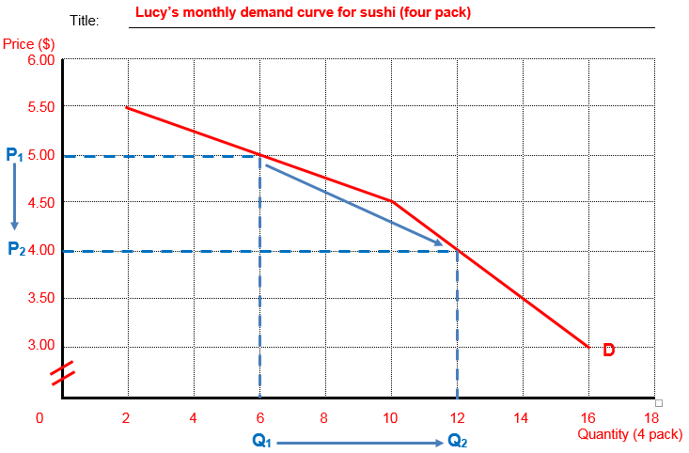
(c) | The law of demand states that as the price decreases, the quantity demanded increases and vice versa, assuming ceteris paribus (all other factors remain unchanged). In this case, as the price of sushi falls from $5 (P₁) to $4 (P₂) per pack, Lucy will increase her quantity demanded from 6 (Q₁) to 12 (Q₂) packs of sushi per month.  This is because Lucy can now afford to buy more packs of sushi per month using her fixed amount of income / assuming her income remains unchanged (ceteris paribus).  She may also prefer to buy more sushi as now sushi is relatively cheaper compared to a substitute good like soup, assuming the price of soup remains unchanged (ceteris paribus).
(d) | Possible flow-on effects:  - purchase more complementary goods to go with the sushi, e.g. she may buy more sauce sachets, a drink etc to go with the sushi  - purchase fewer substitute goods like soup as they are now relatively more expensive  - her spending on sushi has increased from $30 to $48 so she will have less money available to spend on other goods and services

Achievement | Achievement with Merit | Achievement with Excellence
Demonstrates understanding by:  - drawing the graph with FIVE correct requirements (from: title, price ($), quantity, points correct, D label, scale correct)  - identifying accurate movement down the demand curve  - describing the law of demand  - explaining an increase in packs of sushi demanded  - explaining flow-on effect(s). | Detailed explanation, which includes fully explaining:  - the law of demand, with reference to the information in the resource or the graph, or  - the change in the number of packs of sushi demanded by Lucy  - flow-on effect(s) for Lucy.  Candidate uses detailed explanations and makes some reference to the graph. | Comprehensive explanation, which includes:  - fully explaining the law of demand in the context of the number of packs of sushi demanded by Lucy, (with reference to the graph and / or schedule)  - fully explaining TWO flow-on effects for Lucy.  Candidate refers to the changes in the graph and uses correct data and economic terminology.

Question Three | Sample answers / Evidence
(a) | Sushi and soup are substitutes for Lucy as they can both be used by her for the same purpose, in this case to be eaten for lunch.
(b)  (c) | 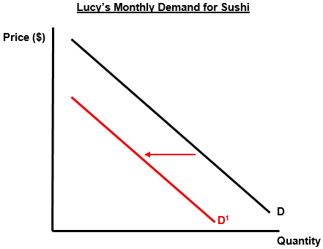  When the price of soup decreases the quantity of soup demanded by Lucy will increase as the soup is now relatively cheaper compared to a substitute, sushi. Lucy switches her lunchtime spending from sushi to soup, causing a decrease in her demand for sushi and a shift of her demand curve for sushi to the left from D to D¹.
(c) | As Lucy is purchasing more soup she may demand more of a complementary good like a roll to go with her soup.  Lucy may be spending less money on soup than she used to on sushi so may have more money available to spend on other goods and services.  Lucy may be spending more money on soup and a roll than she used to spend on sushi so she may have less money to spend on other goods and services.

Achievement | Achievement with Merit | Achievement with Excellence
Demonstrates understanding by:  - identifying substitute  - shift left of demand curve  - describing more soup purchased  - explaining less sushi demanded  - identifying flow-on effect | Detailed explanation, which includes:  - explaining substitute, in terms of being used instead of another  - fully explaining increase in quantity of soup purchased  - fully explaining shift left of demand curve for sushi, with some reference to the graph  - explaining flow-on effect.  Candidate uses detailed explanations and makes some reference to the graphs. | Comprehensive explanation, which includes:  - fully explaining substitutes, in terms of being used instead of another in the context of Lucy’s lunchtime choices, with reference to graph change  - fully explaining flow-on effect.  Candidate refers to the changes in the graphs and uses correct economic terminology.

Question Four | Sample answers / Evidence
(a) | Inferior goods are more often bought when a person has a lower income, and the goods are often of lower quality. When Lucy was a university student she had a low income so tended to purchase instant coffee, an inferior good.  Luxury goods are often of higher quality, and people buy proportionally more of these as their income increases. Now that Lucy has a job with a city law firm her income is higher so she can afford to purchase higher quality, café bought coffee.  As Lucy’s income increased after her graduation her demand for inferior goods, eg instant coffee, decreased as she could now afford better quality goods like café bought coffee. As she never purchased café coffee at university there was a more than proportional increase in her demand for café coffee as her income increased, making café coffee a luxury good.
(b) | Possible positive flow-on effects:  - Lucy may get more enjoyment from drinking coffee as she is now drinking higher quality coffee  - Lucy may tend to buy more complementary goods for coffee, eg a muffin / slice of cake etc, as they are more readily available at the café  - Lucy may create new friendships as she is spending more time socialising at the café.

Achievement | Achievement with Merit | Achievement with Excellence
Demonstrates understanding by:  - identifying that the job has increased Lucy’s income  - identifying instant coffee as inferior  - identifying café coffee as luxury  - defining inferior goods  - defining luxury goods  - identifying the changes in demand for both types of coffee  - describing flow-on effect. | Detailed explanation, which includes fully explaining:  - why instant coffee is an inferior good and café coffee is a luxury good  - the effect of her job on income and the demand for both types of coffee  - flow-on effect explained.  Candidate uses detailed explanations mostly in context | Comprehensive explanation, which includes fully explaining:  - luxury and inferior goods fully explained in relation to Lucy’s job and income  - links increased income with less demand for inferior and a more than proportional increase in demand for luxuries  - fully explains flow on effect.  Candidate uses full explanations in context and uses correct economic terminology.

Cut Scores
Not Achieved | Achievement | Achievement with Merit | Achievement with Excellence
0 – 8 | 9 – 17 | 18 – 24 | 25 – 32

