PNBHS Printing: 892nmyy
On the side of STRATUS you will find a link MS TEAMS (click on it)
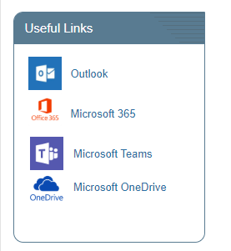
You are now in MS TEAMS – if you have been added to a team it will be in this list.
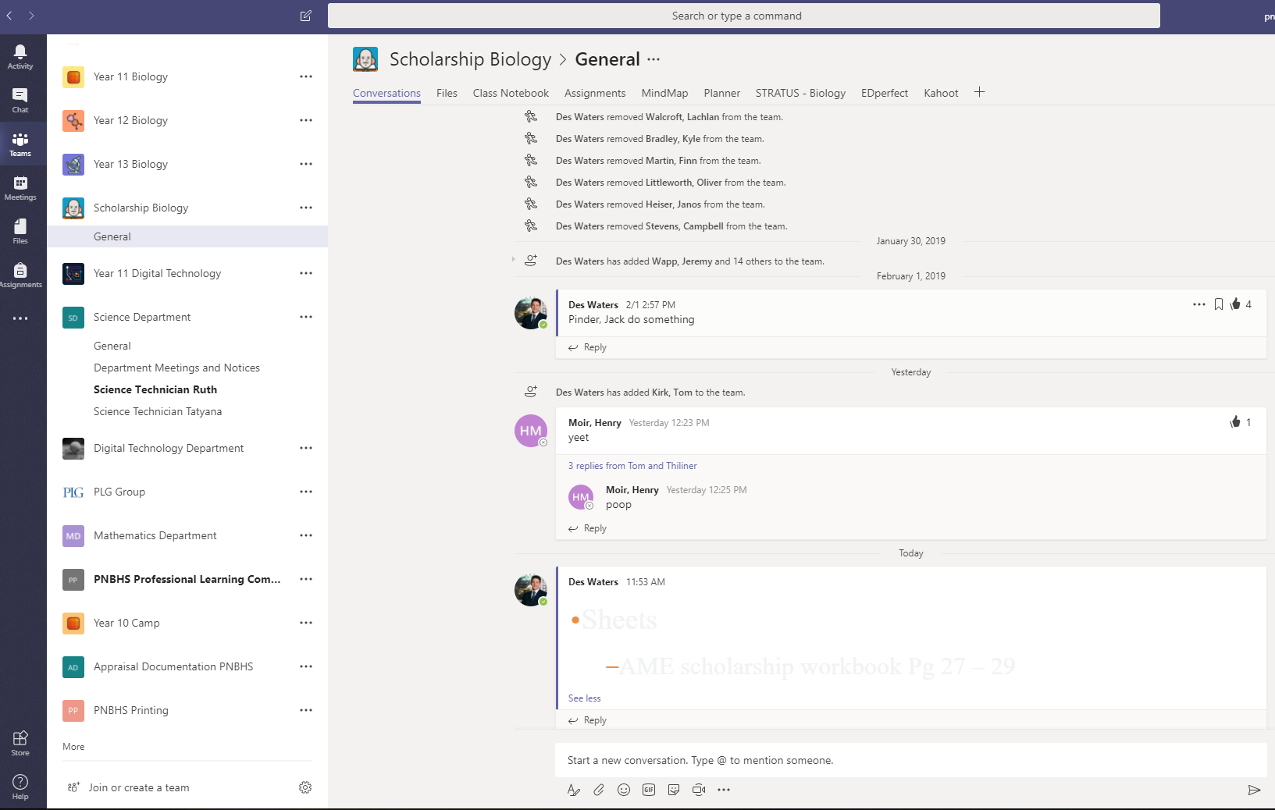

If you are not in a team that is ok. You have two options:
- Join a team (i.e. the PNBHS printing – use the code at the top of the page)
  - Jordan has made Department teams for those who don’t have one already
  - See STRATUS for all the Team codes (Staff ICT administration)
- Create a team
Teacher – for your class
PLG group
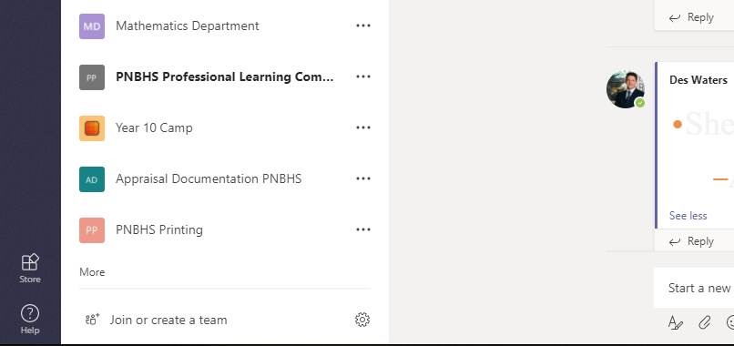

You will go through the setup – just follow the instructions.
Once you have a team you will see things like ‘FILES’:
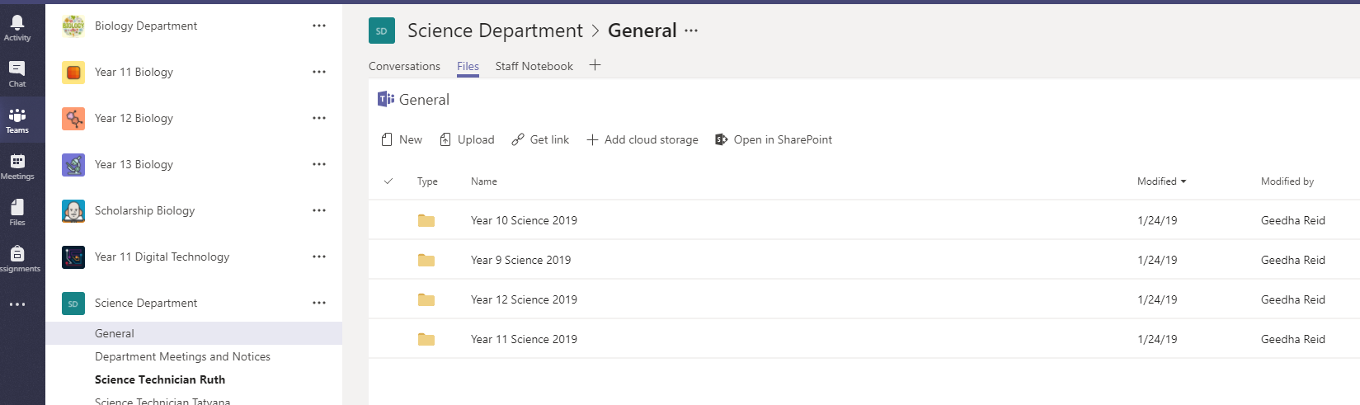
Files are stored under the files tab in your team
Drag and Drop files in to that folder – this is where you will find you g:drive resources in the coming weeks.

