If you want to view your Microsoft Team Files in File Explorer follow these instructions
These files are the same on and offline (if you delete them in either place they will be deleted, if you create a folder in either place you will see it).
This is what your team files will look like:
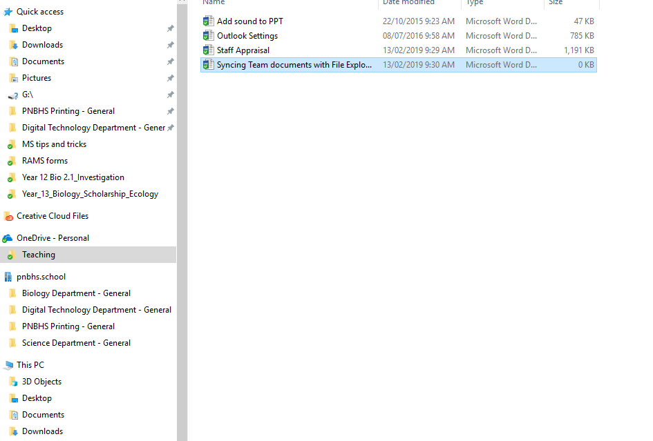

- Open Microsoft Teams and select the teams with the files in it you want to sync (have access to without going through MS Teams all the time).
  - i.e. the ‘Science Department’
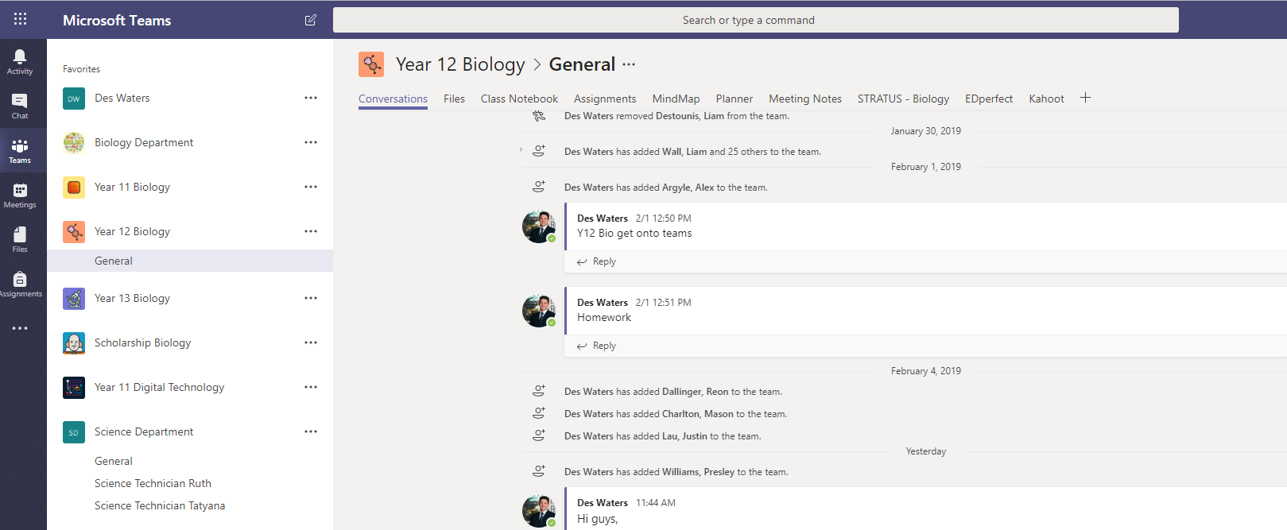
- Now that you are looking at the MS Team you want – Select files at the top
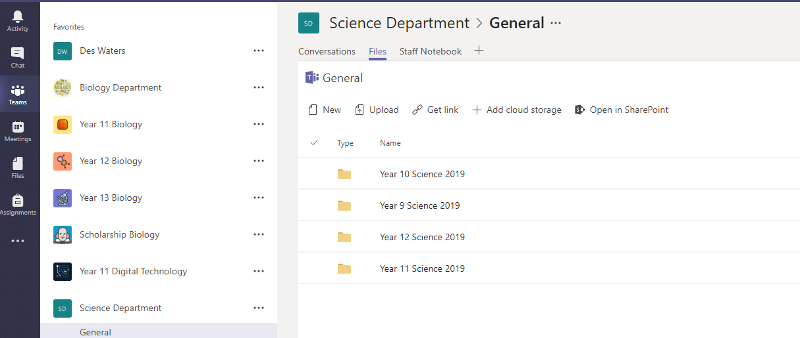
- Click ‘Open in Sharepoint’
- Click ‘Sync’
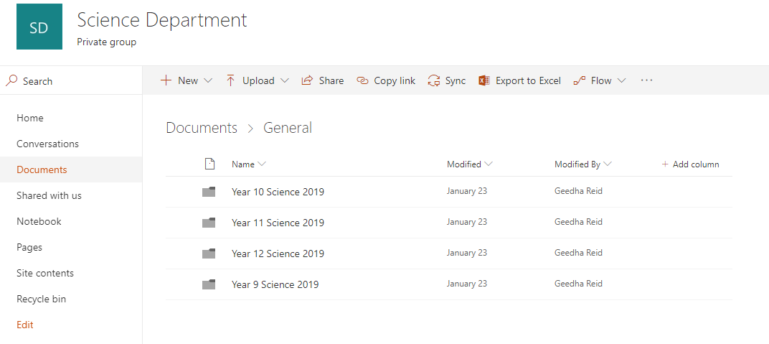
- Click Open in Microsoft OneDrive
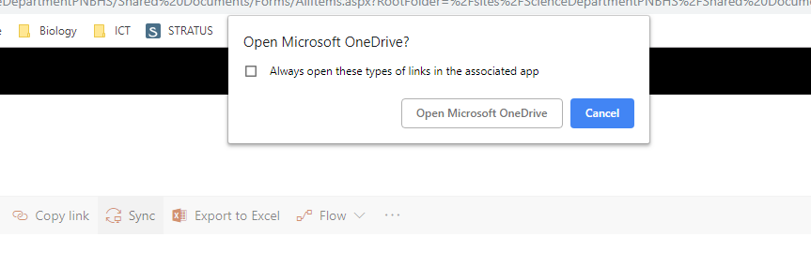
- You will now see your files in File Explorer – You can add make changes there from now on if you don’t want to go through teams.
