Using Microsoft Forms
- Open Stratus
- Go to the right-hand side of the page
- Click on Microsoft 365
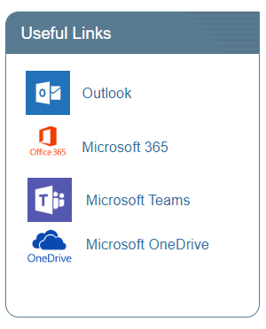
- Select forms
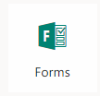
- Create a form by clicking on NEW FORM
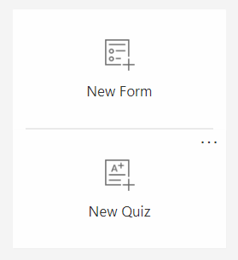
- Once you have made your form you share it by clicking on share
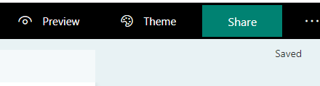
- Share the link and you are done – the results will be in a Excel format.
- To get the results click on the Responses tab in the form and export to Excel if you want/
