How to get Microsoft Teams on your task bar (bar at the bottom of your computer)
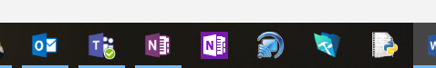
- Go to STRATUS
- Click on ICT HELP
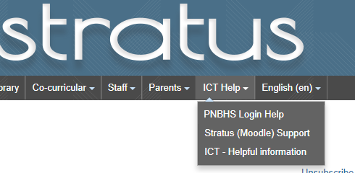
- Click on DOWNLOAF for MICROSOFT TEAMS
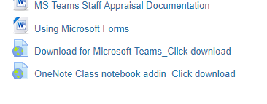
- Click on download
- Follow the instructions and sign in
- Once the Microsoft Teams app is up and running, right click on it and select PIN to TASKBAR
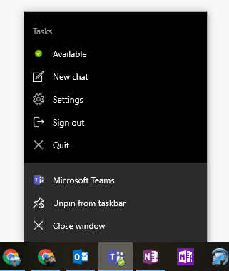
Now all you have to do is click on it to access your Microsoft Team (no need to go through STRATUS)

