Create read-only files for class teams

*Microsoft Teams for Education*

If you want to share files with your students in a class but you don't want them to be able to edit those files, here's the best way to do it.

1. Navigate to a channel in the class team where you plan to share files. Channels are listed underneath the name of your class.
2. Select the **Files** tab, then **Open in SharePoint**. SharePoint will open in your web browser and show you the file structure for your team.  
     
   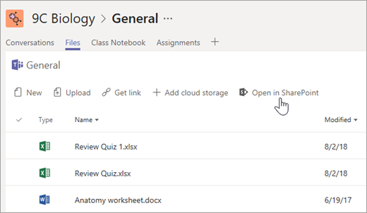
3. Select **+ New**>**Folder**. Name your folder and select **Create**.
4. Right-click on or select the **Show actions** button (the vertical "**...**" button that appears when you select the folder) for the folder you just created and select **Details**.  
     
   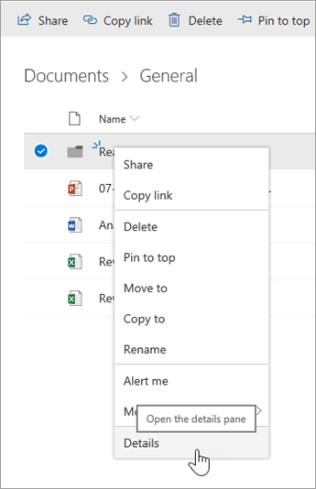
5. Select **Manage access** in the Details pane.
6. Beneath **Members**, select the dropdown arrow and then **Change to view only**.  
     
   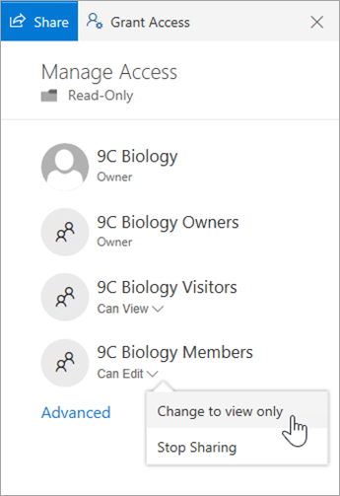

From now on, add any files you don't want students to edit to this folder. You can add files to the folder from Teams or SharePoint--your changes will sync back and forth.