Students: Seeing online lesson on MS TEAMS
Students need MS teams to be open in order to get the meeting notification, but they will get an email reminder as well anyway.
- The student goes to the MS CALANDER after opening MS TEAMS
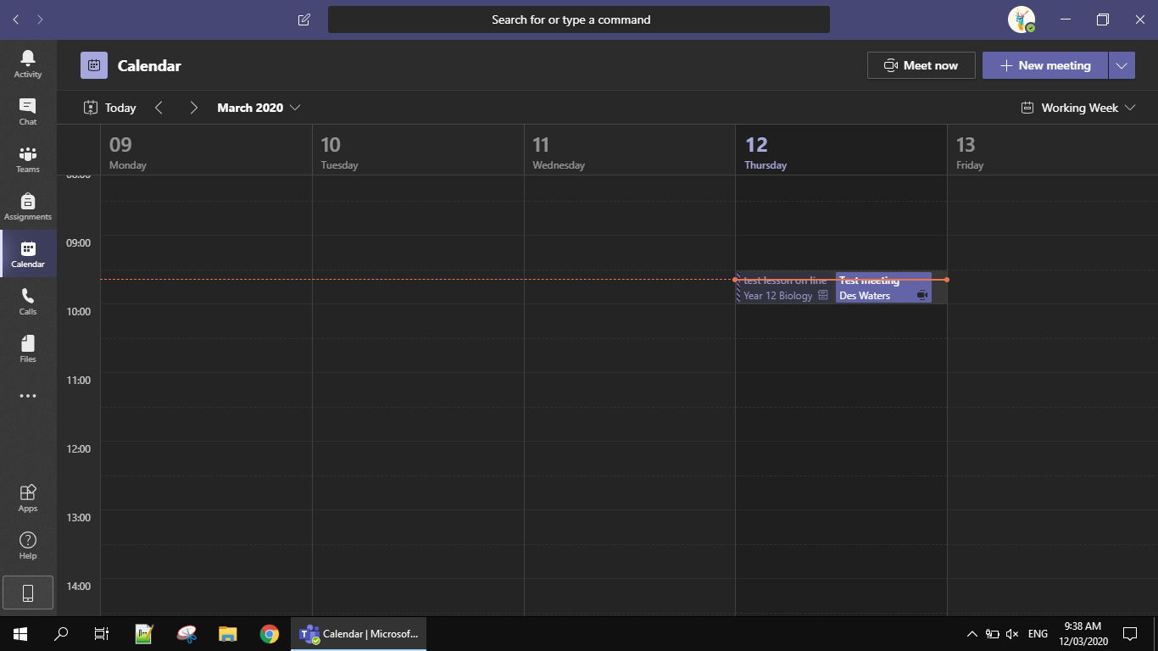
- They then click on the meeting/class they have
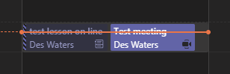
- They then need to join the meeting
- Click ‘Join Now’
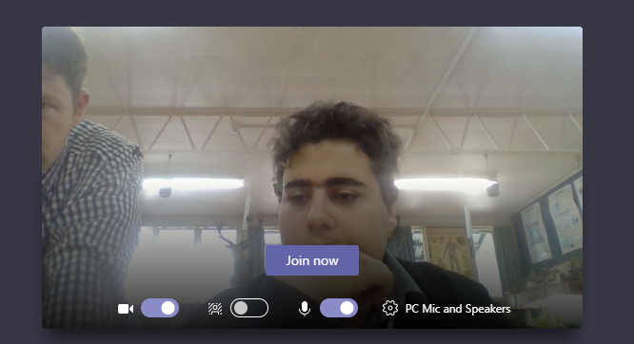
- This is what the student will see
