The history of Melodrama as a form of Drama
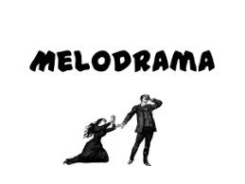

When: Melodrama first appeared around 1800 and gained much popularity with middle and lower socio-economic classes. They were extremely popular in Victorian times (1837 – 1901) when the rich and powerful had tremendous authority over ordinary people.

Purpose: to offer escapism* from the monotonous ‘daily grind’ of the poor/lower class and also to reassure audiences that strength and goodness do exist.
*escapism means the lower class got emotional relief from the performance which allowed them to forget the harshness of their own lives.

- This was the time New Zealand was being settled by Europeans, many of whom came from poor backgrounds in Britain.
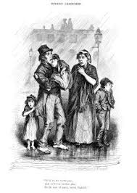
- In New Zealand and England, life was tough for the poor and they had to struggle to stay alive.
- It was a time of enormous change as machinery began to take over many labouring jobs. This was called the Industrial Revolution which made many factory owners very rich (because machines worked faster and produced more, than people), and made those without jobs, very poor.
- There was a very limited welfare system so that if you did not work, you had no little or no money to buy food or pay rent and became homeless. Consequently, petty crimes such as theft, drunkenness, prostitution and vagrancy were very common amongst the poor.
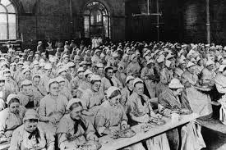
- Some employers and rent collectors were also dishonest, cruel and uncaring. Poor people became angry and blamed those with power and money for their bad situation.
- There were limited things that people could do for entertainment because they had very little money. One thing that was affordable was going to live melodrama.
- Poor people could directly relate to melodrama’s plots where the villain was a rich person who took advantage of the poor or innocent.
- Writers of melodrama realised this and wrote their plays to appeal especially to the poor. Thus the dramatic form of melodrama was developed because of the audience’s demands.
- Theatres were often huge to accommodate large audiences. This allowed seats to be sold more cheaply. London’s Drury Lane Theatre held 3,500 people and had a stage that was 30m deep! (The Speirs Centre holds 368, The Regent 1500)
- Actors had to use very large gestures and strong voices so big audiences at the back could see and hear what was going on.
- The audience got very emotionally and vocally involved in the performances, booing the villain and supporting the victim(s). They loved the suspense, suffering, evil deeds, romance and heroism, and the fact that Melodrama always shows good suffering at the hands of evil with good triumphing over evil in the end.

Features of Melodrama
- The plot is normally about an attempt by the villain to abuse his position of power for his own gain. However, goodness always triumphs over evil in melodrama. The hero always defeats the villain which often involves rescuing a damsel (innocent
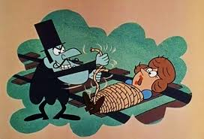
young woman) in distress.

- Stock Characters:
The villain represents evil. He is powerful and usually wealthy and abuses his power. He is greedy, selfish and capable of violence.
The villain’s sidekick supports the villain and will stand by him. He does not have intelligence and is often abused by the villain. The villain will often tell the sidekick has plans which allows the audience to share in the thoughts.
The heroine represents goodness, is vulnerable and needs protection but is courageous. She tells the truth and is honest. She will be under threat from the villain. A “damsel in distress” needing rescue.
The hero is brave, honest, true and noble. Will protect the damsel and is committed to her.
The hero's sidekick supports the hero and will stand by him. He is honest and true. The hero will often tell the sidekick has plans which allows the audience to share in the thoughts.
Other characters also regularly appear such as the faithful servant who is loyal and hardworking.
- Fast-paced plots to keep the audience interested
- Originally had to include music between scenes.

Use of drama techniques (acting style) in Melodrama
- exaggerated gestures. For example, the villain sneering at someone in trouble or the damsel putting a hands on her forehead to show distress.
- speaking directly to the audience which breaks the fourth wall. Includes asides to the audience when a character speaks directly to the audience about their thoughts and feelings which other characters cannot hear.
- Direct, strong and clearly articulated voices.
- Accents reflecting the character’s social status
- A melodrama play contains high emotion and exaggerated feelings.

Conventions of melodrama (common ways of working in melodrama)
- use of the aside (gives the audience knowledge other characters are unaware of)
- concealed identity
- musical score underpinning tension (when possible)
- abductions
- disguise
- song and dance
- audience interaction – pro hero/heroine, anti villain
- mistaken identity
- dramatic tableau (brief freezes for dramatic effect to increase emotion)
- codified gestures (specific gestures for certain reactions, recognised by the audience):
Horror – open mouth, wide eyes, both hands on cheeks
Grief – shoulders hunched forward, hands cover face, head down, sobbing
Bravery – chest out, straight spine, open palms, strong eye contact
Fear – turning away, hand over mouth, hands up protectively

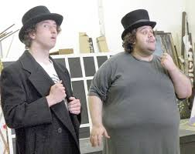
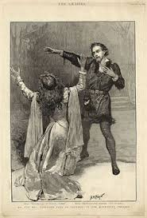

Who is who and how can you tell?

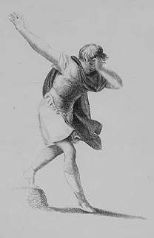
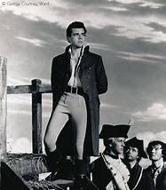

Chris Burton
PNBHS Drama 2020

