Palmerston North Boys’ High School

GEOGRAPHY
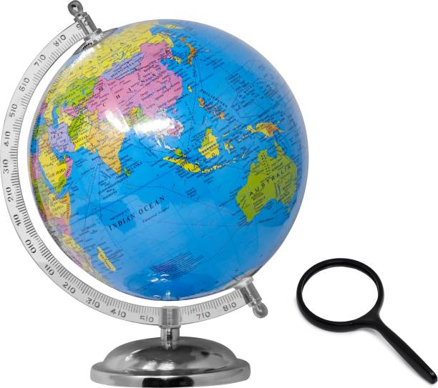
SOME GEOGRAPHIC CURRENT ISSUES

PLANNING FOR CLIMATE CHANGE RESOURCE MANAGEMENT ACT CHANGES

COVID-19 DISRUPTS WORLD ECONOMIES NEW ZEALAND POPULATION PASSES 5 MILLION

IMMIGRATION TO NEW ZEALAND ONE MILLION SPEICIES IN DANGER
BRINGS NEW SKILLS OF EXTINCTION

PEST FREE NEW ZEALAND BY 2050

NZ SEEKS TO EXPAND RENEWABLE ENERGY SOURCES WITH INCREASED DEMAND

FAMILY DENIED BUILDING CONSENT FOR COASTAL PROPERTY

"The study of geography is about more than just memorizing places on a map. It's about understanding the complexity of our world, appreciating the diversity of cultures that exists across continents. And in the end, it's about using all that knowledge to help bridge divides and bring people together." BARACK OBAMA

Careers in Geography
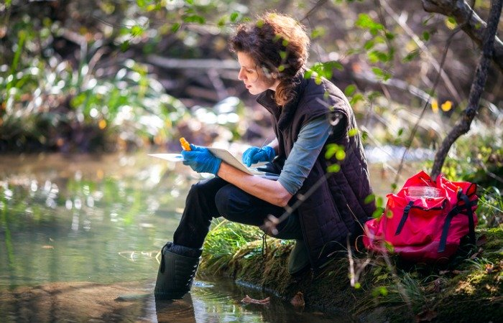
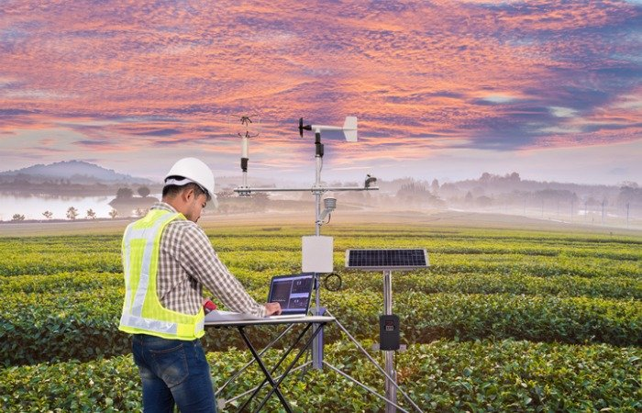

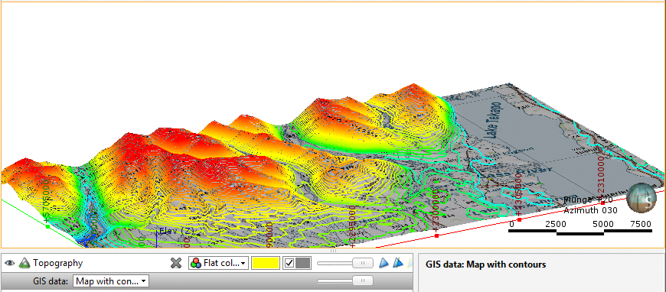
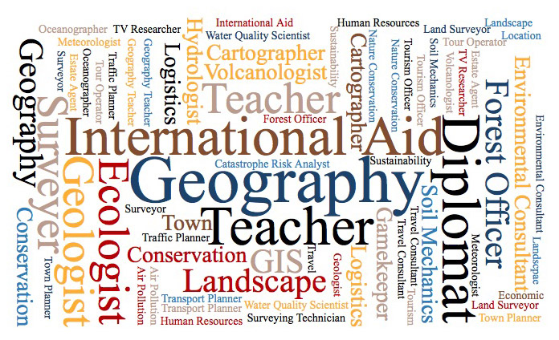
‘Contemporary geography is much less about where places are – though this is useful knowledge – but the ways in which physical and social processes differentiate the earth. It therefore splits into physical geography where you learn about geo-physical processes (such as plate tectonics, soil formation and climate) and human geography where you would consider the ways economies, cultures and societies create very different places”.

In 2018 the average income for Geographers was $80 300 (BLT)

GEOGRAPHY AT PNBHS
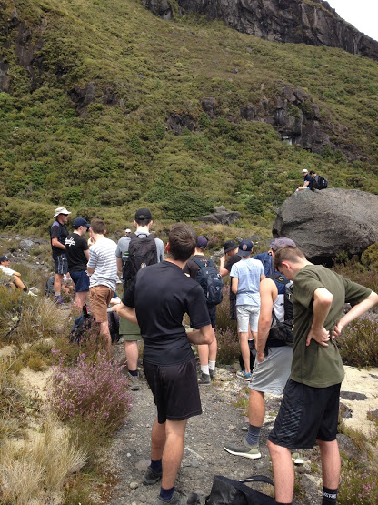
- Geography is taught at NCEA Levels 1, 2 and 3
- Scholarship geography and Massey papers are also offered.
- Students participate in a range of fieldtrips. These
include the Manawatu, Wellington, Tongariro and
Rotorua.
- All levels involve field research (an integral part of
geography) and geographic skills. These transfer to a
wide variety of fields and occupations.
- GIS (Geographic Information Systems) is an ever-
increasing component of geography. This is taught at
all levels.

LEVEL 1 GEOGRAPHY: (4 Internal Credits, 4 External Credits)
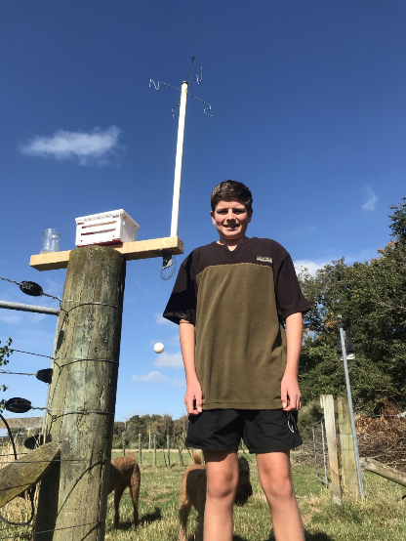
- Study the world of physical geography, where you will
examine the forces that create and shape our unique
landscape. Understand and evaluate the impact of humans on these landscapes and appreciate that we are guardians
of these landscapes and must ensure they are available for
the enjoyment and use of future generations (kaitiakitanga).

- Create your own weather station, and compare its accuracy with those more expensive ones used by Metservice and NIWA. Understand the forces that influence our climate and apply this knowledge to real life situations.

- Introduce yourself to the world of GIS (Geographic Information Systems) and its hundreds of uses in law and order, resource management, military, urban planning, forestry, conservation, social planning, water conservation, commerce, retail…the list is endless.

- Want to buy or sell a house in the future, start up a business, become a property developer? Learn about the importance of population dynamics (demography) in determining the success of your venture. Understand the causes of our population patterns to enable you predict future patterns and trends…a failure to plan is planning to fail.

LEVEL 2 GEOGRAPHY: (8 Internal Credits, 12 External Credits)
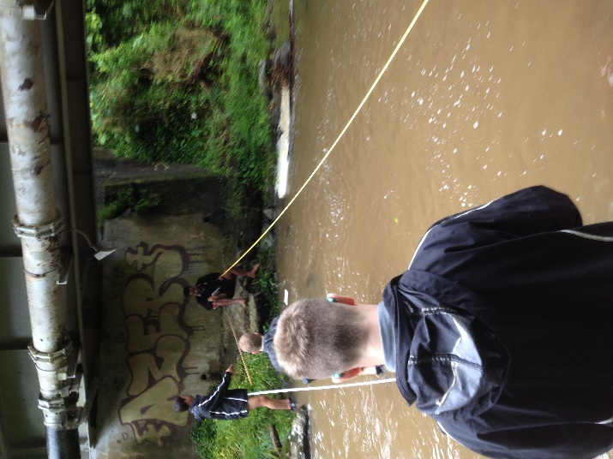
- Further reinforce your understanding of physical geography, but this time, bring it home. Study the mighty Manawatu as you have never studied it before. Understand that the same forces that have produced the cataclysmic events of the past, are the same forces that have produced and continue to evolve the Manawatu landscape today. Examine the impact of human activity on the Manawatu and how these attitudes and perspectives must change if we wish for a sustainable future. Gather and record information regarding fluvial processes and the impact they have on the Manawatu’s natural and cultural environments.

- Study the unequal distribution of wealth and resources, using Tanzania as a case study. Understand that inequality occurs at a local, regional, national, and global scale. Explain the causes and consequences of inequality in Tanzania and the ways different groups and governments aim to address and lessen the impacts of inequality. Reinforce your understanding of GIS with this real-life example.
LEVEL 3 GEOGRAPHY: (11 Internal Credits, 12 External Credits)
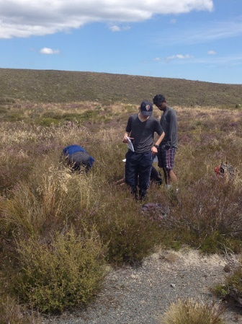
- Now it’s real. You can call yourself a geographer. Study, in-depth, the forces of geography that have created and shaped the central volcanic zone. Experience the unparalleled violence of nature as it creates and destroys the central plateau over millennia.

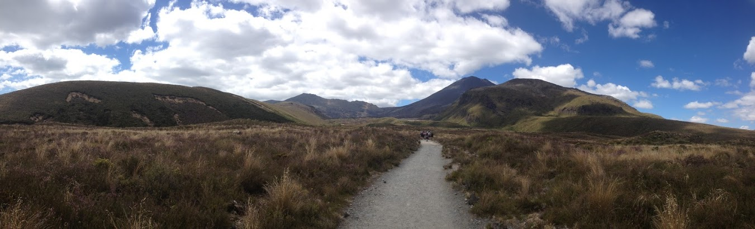
- Finally, study the past, present and future of tourism in Rotorua and how the natural landscape has changed as a result. Appreciate, like all cultural activities, that tourism is affected by a range of natural and cultural processes, some of these positive and others negative. Evaluate the effects of covid-19 on tourism and possible steps to recovery for Rotorua and New Zealand.

